OPTIMAL DESIGN OF TUNED MASS DAMPER FOR HORIZONTAL IRREGULAR BUILDING USING GENETIC ALGORITHM

A FINAL YEAR PROJECT REPORT
submitted by
AISHWARYA VAJA (U22CE004)
STUTI SINGH (U22CE067)
SHREYA PATEL(U22CE069)
SANDHYA KUMARI(U22CE077)

in partial fulfilment of the requirements for the award of the degree of

BACHELOR OF TECHNOLOGY
in
CIVIL ENGINEERING
under the supervision of

Dr. Vishisht Bhaiya
(Assistant Professor)


DEPARTMENT OF CIVIL ENGINEERING
SARDAR VALLABHBAI NATIONAL INSTITUTE OF TECHNOLOGY SURAT
DECEMBER 2025
CERTIFICATE
This is to certify that the Final Year Project Report entitled “OPTIMAL DESIGN OF TUNED MASS DAMPER FOR HORIZONTAL IRREGUALR BUILDING USING GENETIC ALGORITHM” submitted by AISHWARYA VAJA (U22CE004), STUTI SINGH (U22CE067), SHREYA PATEL (U22CE069), and SANDHYA KUMARI (U22CE077) to Sardar Vallabhbhai National Institute of Technology, Surat, in partial fulfilment of the requirements for the award of the degree of Bachelor of Technology in Civil Engineering, is a bona fide record of work carried out by the students under my supervision.
The contents of this report, either in full or in part, have not been submitted to any other Institute or University for the award of any degree or diploma

DR. V. L. MANEKAR  Head of the Department  Civil Engineering | DR. VISHISHT BHAIYA  Assistant Professor  Department of Civil Engineering  S.V. National Institute of Technology  Surat

Surat
Date:

CERTIFICATE OF APPROVAL

This is to certify that the Final year project report entitled “OPTIMAL DESIGN OF TUNED MASS DAMPER FOR HORIZONTAL IRREGUALR BUILDING USING GENETIC ALGORITHM” submitted by AISHWARYA VAJA (U22CE004), STUTI SINGH (U22CE067), SHREYA PATEL (U22CE069), and SANDHYA KUMARI (U22CE077) to the Sardar Vallabhbhai National Institute of Technology Surat, in the partial fulfilment of the requirements for the award of the degree of Bachelor of Technology in Civil Engineering has been accepted by the examination committee and that the student has successfully completed the examination held today.

DR. VISHISHT BHAIYA

(Internal Examiner) (External Examiner)

Place: Surat
Date:

ACKNOWLEDGEMENTS
I have taken endeavors in the Final year project. However, this would not have been possible without the kind support of many individuals. I am highly indebted to the respected Head of the Department, Dr.V. L. MANEKAR, Department of Civil Engineering, SVNIT, Surat, for allowing me to present my Final year project on OPTIMAL DESIGN OF TUNED MASS DAMPER FOR HORIZONTAL IRREGUALR BUILDING USING GENETIC ALGORITHM. I sincerely thank my Final year project guide, DR. Vishisht Bhaiya, Department of Civil Engineering, SVNIT, Surat, for their valuable guidance, constant supervision and for giving necessary information. I extend my gratitude to the B.Tech Final year project coordinators Dr. S.R. Suryawanshi (Associate Professor), Dr. Vishisht Bhaiya (Assistant Professor), Dr. Smaranika Panda (Assistant Professor) for their tireless efforts, invaluable guidance, and unwavering support throughout the Final year project organization. I would also like to thank my parents and friends for their cooperation & perpetual encouragement, which helped me complete this final year project successfully.

AISHWARYA VAJA (U22CE004)
STUTI SINGH (U22CE067)
SHREYA PATEL(U22CE069)
SANDHYA KUMARI(U22CE077)

ABSTRACT
"Optimal Design of Tuned Mass Damper For Horizontal Irregular Building Using Genetic Algorithm" focuses on enhancing seismic performance of multi-storey reinforced concrete buildings in India's seismic Zone III. It integrates IS code-compliant design, 3D modeling with OpenSeesPy, and Genetic Algorithm optimization to tune mass dampers (TMDs) for reducing inter-storey drift and roof displacement in regular and irregular buildings under near-field (Rendil) and Far-field (Kobe) earthquakes.

The methodology includes preliminary structural sizing as per Indian standards, nonlinear time-history analyses with scaled earthquake records, and GA-based optimization of TMD parameters including mass, frequency, damping, and placement. Both single and dual TMD configurations are evaluated for effectiveness.

Results show TMDs significantly reduce peak drifts by 30-50%, with dual TMDs especially effective in controlling torsional irregularities in L-shaped buildings. Far-field (Kobe) motions allow better TMD resonance than near-field (Rendil) pulses. Different optimization strategies reveal trade-offs between drift and displacement control, offering practical design insights.

The study validates an automated computational framework that applies code-based designs, advanced modeling, and heuristic optimization to deliver seismic resilience improvements while identifying limitations like linear elastic assumptions and fixed damping. It provides a foundation for future research on nonlinear behavior, soil-structure interaction, and adaptive control in seismic design, filling a gap in Indian code guidance for vibration control devices.

TABLE OF CONTENT

CERTIFICATE OF APPROVAL iii
ACKNOWLEDGEMENTS iv
ABSTRACT v
TABLE OF CONTENT vi
LIST OF TABLES viii
1. INTRODUCTION 1
1.1 Background 1
1.2 Indian Code Framework and Zone III Specifics 2
1.3 Research Motivation 3
2. LITERATURE REVIEW 4
2.1 Classical Foundations of Tuned Mass Dampers 4
2.2 Extensions and Modern Adaptations of TMD Theory 5
2.3 Seismic Versus Harmonic Loading: Challenges for TMD Design 5
2.4 Computational Approach: Genetic Algorithms in TMD Optimization 5
2.5 Handling Plan Irregularities: Importance of Dual TMDs and Torsion 6
2.6 OpenSeesPy and Its Role in Advanced Structural Seismic Analysis 7
2.7 Indian Seismic and Structural Codes and the Gap for Vibration Control Devices 7
2.8 Near-field (Rendil) versus Far-field (Kobe) Ground Motions 7
2.9 TMD Effectiveness 8
2.10 Inter-Storey Drift as Performance Metric 9
2.11 Technical Objectives 10
2.12 Scope of Work 11
3. METHODOLOGY 12
3.1 Overall Computational Framework 12
3.2 Preliminary Structural Design (IS 456:2000 Compliant) 12
3.3 OpenSeesPy Model Generation 12
3.4 Ground Motion Processing and Scaling 13
3.5 Nonlinear Time-History Analysis Setup 13
3.6 TMD Implementation and Den Hartog Initial Tuning 13
3.7 Genetic Algorithm Optimization Theory and Implementation 13
3.8 Inter-Storey Drift Analysis 14
3.9 Displacement-Based Analysis 14
3.10 Combined Drift-Displacement Optimization 14
3.11 Seismic Ground Motion Analyzer 15
4. OPTIMIZATION AND IMPLEMENTATION TECHNIQUE 17
4.1 Genetic Algorithm-Based Optimization 18
4.2 Parameter Encoding and Search Space 19
4.3 Integration with Structural Modeling 19
4.4 Multi-Objective Considerations and Constraints 19
4.5 Node Selection and Torsional Effects 19
4.6 Implementation Workflow and Performance Monitoring 20
5. RESULTS AND DISCUSSION 21
Preliminary Structural Design (IS 456:2000 Compliant) 26
6. CONCLUSION AND FUTURE SCOPE 35
6.1 Summary of Research 35
6.2 Key Findings 35
6.2.2 TMD Performance for Irregular Buildings 36
6.3 Limitations of the Study 38
6.4 Recommendations for Future Research 39
7. REFERENCES 41
APPENDIX 45

LIST OF TABLES
Table 1: Optimization Results for 15-Story Building (Far-field (Kobe)) 24
Table 2: Optimization Results for 5-Story Building (Far-field (Kobe)) 28

LIST OF FIGURE
Figure 1: Three-Dimensional View of Five-Storey RC Moment-Resisting Frame Building with 6 m × 6 m Bays 1
Figure 2: Classical foundation of tunned mass damper 4
Figure 3: Dual TMDs 6
Figure 4:Acceleration time history of Kobe (1995) earthquake ground motion record. 15
Figure 5: Acceleration time history of selected near-field (Rendil) ground motion record 16
Figure 6: Inter storey drift profile under El centro (far field) ground motion for 15 storey building with and without TMD 21
Figure 7: Comparison of maximum roof displacement reduction for near-field (Rendil) and Far-field (Kobe) ground motions using optimized TMD. 22
Figure 8: Inter-storey drift profile under RENDIL (near-field (Rendil)) ground motion for 15-storey building with and without TMD. 23
Figure 9: Roof displacement time history under NEARFIELD1 ground motion for 15-storey building with and without TMD. 24
Figure 10: Roof Displacement Time History under El Centro Ground Motion 25
Figure 11: Inter-storey Drift Profile of Five-Storey Building under El Centro Ground Motion 26
Figure 12: Roof Displacement Time History of Five-Storey Building under RENDIL Ground Motion 27
Figure 13: Inter-storey Drift Profile of Five-Storey Building under RENDIL Ground Motion 28
Figure 14: Ground Motion Time History for Record RENDIL 29
Figure 15: Maximum Inter-Storey Drift Profile for Ground Motion RENDIL (With and Without TMD 30
Figure 16: Roof Displacement Time History for Ground Motion RENDIL (With and Without TMD. 31
Figure 17: Time-history of Ground Motion RENDIL. 31
Figure 18: Maximum Inter-storey Drift Profile with and without TMD for RENDIL. 32
Figure 19: Roof Displacement Time-History with and without TMD for RENDIL 33

INTRODUCTION

1.1 Background
Multi-storey reinforced concrete buildings dominate urban infrastructure across India's seismic zones II through V, where earthquake ground motions ranging from moderate (Zone II: Z=0.10) to severe (Zone V: Z=0.36) pose existential threats to structural stability and human safety. IS 1893 (Part 1):2016 establishes the cornerstone of Indian seismic design philosophy through ductility-based response reduction factors (R=3-5 for SMRF/OMRF systems) and stringent inter-storey drift limits: 0.004h for EL-type structures and 0.0025h for moment-resisting frames, where h represents storey height. These limits ensure serviceability and prevent P-Delta instability under design-basis earthquakes (DBE), yet they primarily address primary lateral force-resisting systems without explicit provisions for supplementary energy dissipation devices.​
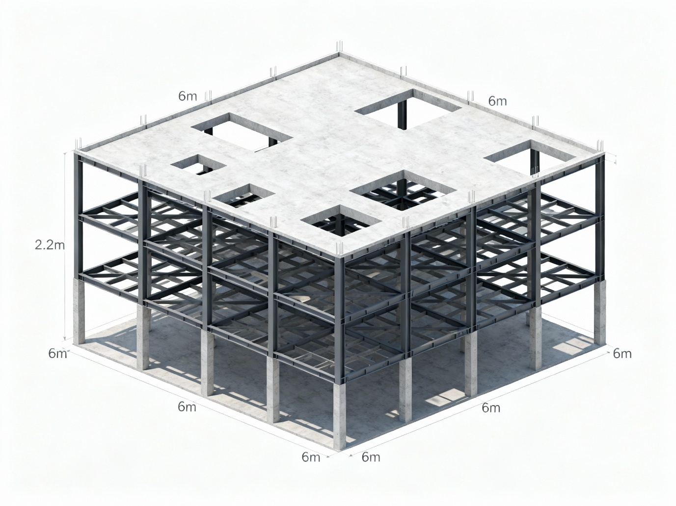
Figure 1: Three-Dimensional View of Five-Storey RC Moment-Resisting Frame Building with 6 m × 6 m Bays

This study focuses specifically on Seismic Zone III (Z=0.16) - representing moderate seismic hazard regions including major urban centers like Surat, Ahmedabad, and parts of Maharashtra, Gujarat, and Madhya Pradesh. Zone III demands balanced design considering both serviceability (frequent earthquakes) and collapse prevention (design basis events), making TMD implementation particularly valuable for cost-effective performance enhancement.
The transition from equivalent static analysis (ESA) to response spectrum analysis (RSA) and nonlinear time-history analysis (NTHA) reflects evolving performance-based seismic design paradigms. ESA provides conservative force envelopes suitable for preliminary sizing but fails to capture dynamic amplification effects. RSA offers modal superposition for regular structures but underestimates torsional demands in irregular plans. NTHA, employing actual accelerograms scaled to Zone III PGA = 0.16g, reveals time-varying displacement histories critical for drift evaluation and vibration control device sizing. Near-field (Rendil) earthquakes (PGA > 0.25g, pulse periods 0.5-2.0s) generate long-period velocity pulses causing directional amplification, while Far-field (Kobe) motions exhibit broadband frequency content better suited for classical response spectrum methods.​
Tuned Mass Dampers (TMDs) represent passive vibration control technology where auxiliary mass-spring-damper systems tuned to primary structure frequencies redistribute seismic energy, achieving 25-60% reductions in peak roof displacement, inter-storey drift, and floor accelerations under Zone III demands. Unlike base isolation (high cost, large plan dimensions) or viscous dampers (limited stroke capacity), TMDs offer practical retrofit solutions for existing high-rises and new constructions exceeding IS 1893 drift tolerances.

1.2 Indian Code Framework and Zone III Specifics
IS 456:2000 governs RC member sizing through empirical span/depth ratios (span/12 for beams, minimum dimensions 230mm width × 450mm depth for typical bays) and development length provisions. IS 875 (Parts 1&2) quantifies dead loads (slab self-weight 25 kN/m³, finishes 1-2 kN/m²) and live loads (3-5 kN/m² office/residential with 25-50% reduction per IS 1893 Table 8 for seismic mass calculation). IS 1893 mandates seismic weight computation as DL + 25%LL, fundamental period estimation T = 0.075h^0.75 for RC moment frames, and Rayleigh damping matrix formulation targeting 2-5% critical damping at first two modes.
Zone III characteristics (Z=0.16) require moderate base shear (V_b = A_h × W = 0.16 × (Sa/g) × (I/R) × W) with design acceleration spectrum peaking at Sa/g = 2.5 for T<0.5s (short period structures). Critical research gaps persist: Indian codes provide no algorithmic procedures for TMD parameter selection (mass ratio μ=1-5%, frequency ratio f=0.95-1.05, damping ratio ζ=5-20%), TMD placement optimization for irregular plans, or performance quantification under site-specific Zone III ground motions. Classical Den Hartog formulas assume undamped single-DOF primaries unsuitable for multi-storey MDOF systems exhibiting closely-spaced modes and Rayleigh damping.

1.3 Research Motivation
This project addresses these gaps through an integrated computational framework combining:
- IS code-compliant preliminary design generating realistic beam/column/slab geometries and seismic masses scaled for Zone III (Z=0.16)
- Automated 3D OpenSeesPy modeling of regular rectangular and L-shaped irregular buildings as elastic MDOF systems
- Nonlinear time-history analysis using Newmark-β (γ=0.5, β=0.25) integration with uniform base excitation scaled to Zone III PGA
- Genetic Algorithm (GA) optimization of single/dual TMD parameters (μ, f, ζ, nodal location) minimizing RMS roof displacement
- Three dedicated analysis scripts targeting inter-storey drift, absolute displacement, and combined performance metrics

LITERATURE REVIEW

2.1 Classical Foundations of Tuned Mass Dampers
Tuned Mass Dampers (TMDs) trace their origins to the classical work of Den Hartog in 1956, whose theory remains central to understanding passive vibration control systems. Den Hartog formulated conditions under which an auxiliary mass-spring-damper system attached to a primary vibrating structure can significantly reduce its dynamic response. His approach identifies optimal tuning of the TMD’s natural frequency and damping to minimize peak displacement amplitudes of the structure when subjected to harmonic excitation. The elegance of Den Hartog’s theory lies in its provision of closed-form formulas that balance energy transfer between the primary system and the damper, ultimately flattening and lowering the resonance peaks in the frequency response. Though originally developed for undamped single-degree-of-freedom systems, these principles laid the foundation for subsequent advancements that incorporate practical damping and multidimensional structural complexities.
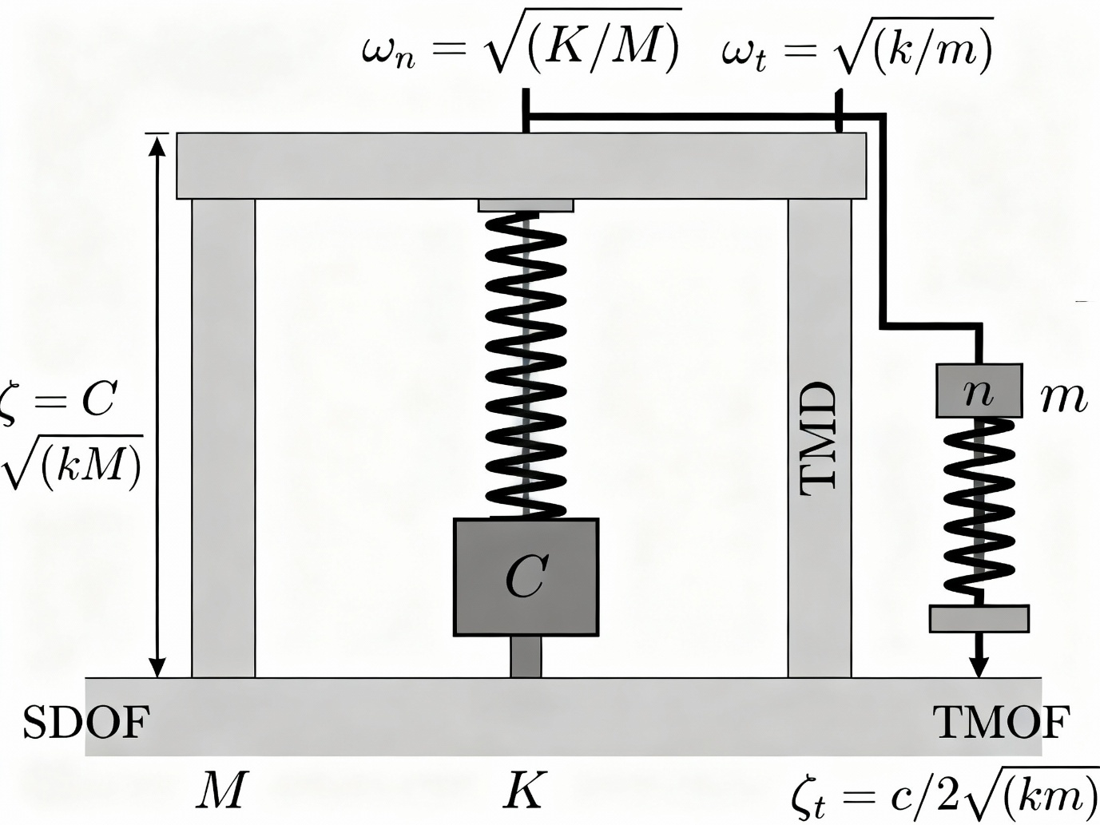
Figure 2: Classical foundation of tunned mass damper

2.2 Extensions and Modern Adaptations of TMD Theory
Building on Den Hartog’s groundwork, researchers extended the theory to encompass the effects of damping present in real structures and to handle multi-degree-of-freedom (MDOF) systems typical of multi-storey buildings. Practical engineering systematic optimizations acknowledge that buildings possess intrinsic damping mechanisms, often modeled by Rayleigh damping, representing hysteretic and viscous characteristics. Extensions to the classical model modify tuning parameters to account for structural damping, which typically leads to slight adjustments in optimum frequency and increased TMD damping levels for effective vibration mitigation.
Furthermore, in MDOF systems, the TMD’s effectiveness strongly depends on its tuning to dominant vibration modes and its placement relative to modal participation factors. For buildings exhibiting irregularities resulting in complex mode coupling, careful dynamic analysis is essential to correctly optimize multiple dampers or tuners such as dual TMD systems for lateral and torsional vibrations.

2.3 Seismic Versus Harmonic Loading: Challenges for TMD Design
While Den Hartog’s theory is apt for steady, harmonic excitations such as wind loading, seismic excitations impose transient, broadband, and non-stationary dynamic forces. Earthquakes, especially near-field (Rendil) pulses, generate velocity pulse-like ground motions with concentrated energy at certain periods, thus challenging classical TMD tuning paradigms. In such cases, robust design approaches tailor TMD parameters to damp multiple vibration modes or widen bandwidths, sometimes employing multiple dampers or adaptive control to maintain efficacy.
Comparative studies find that near-field (Rendil) earthquake records often necessitate stiffer damper tuning and higher mass ratios to counteract their intense but brief pulses. Far-field (Kobe) earthquakes, with generally smoother spectral content, align more closely with classical tuning frequencies, allowing more predictable TMD performance. This distinction underscores the need for seismic-specific optimization strategies integrating robust ground motion data.

2.4 Computational Approach: Genetic Algorithms in TMD Optimization
Optimization of TMD parameters for seismic applications has benefited substantially from heuristic evolutionary algorithms such as Genetic Algorithms (GAs). GAs bypass local minima constraints typical of gradient-based methods by simulating biological evolution mechanisms — selection, crossover, and mutation to explore complex multidimensional parameter spaces. This approach is well-suited for optimizing variables including damper mass ratio, frequency, damping, and location, often simultaneously.
GA frameworks incorporate fitness functions that balance response reduction (e.g., minimizing peak roof displacements or inter-storey drift) and practical constraints (such as limiting total damper mass). This enables automated, repeatable tuning applicable to both regular and irregular building forms subjected to varying seismic inputs, including near-field (Rendil) and Far-field (Kobe) records. The result is more effective and tailored passive control solutions compared to heuristic or deterministic parameter selection.

2.5 Handling Plan Irregularities: Importance of Dual TMDs and Torsion
Irregular building geometries, such as those with L-shaped plans incorporating re-entrant corners, introduce significant challenges via torsional vibrations coupled with lateral modes. This torsional irregularity often results in amplified inter-storey drifts and demands special consideration in seismic control designs. Single TMDs placed centrally are insufficient in disrupting the coupled modes effectively; instead, deploying dual or multiple dampers at spatially separated locations (e.g., orthogonal roof corners) has been shown to reduce both translation and torsional responses more efficiently.
Analytical and numerical modal analyses guide damper placement by identifying nodes exhibiting high modal participation, facilitating strategic damping deployment. This approach has been validated by experimental studies and numerical simulations, reinforcing the necessity of multi-damper systems for complex irregular buildings under seismic excitation.

Figure 3: Dual TMDs

2.6 OpenSeesPy and Its Role in Advanced Structural Seismic Analysis
OpenSeesPy, an open-source Python interface to the Open System for Earthquake Engineering Simulation (OpenSees), provides a highly flexible framework capable of simulating detailed 3D elastic and inelastic structural behaviour under realistic ground motions. Its ability to model multi-degree-of-freedom systems with precise control over element types, boundary conditions, and damping models enables sophisticated time-history analyses critical for seismic performance evaluation.
OpenSeesPy supports custom element definitions such as two-node links representing Tuned Mass Dampers with parallel mechanical properties, allowing seamless integration of control devices into structural models. The platform’s open design fosters coupling with optimization algorithms such as Genetic Algorithms, streamlining the iterative design and analysis workflow essential for contemporary performance-based seismic engineering.
Validations of OpenSeesPy models for multi-storey reinforced concrete frames have demonstrated high fidelity in replicating response characteristics, facilitating its adoption in both research and practical design contexts.

2.7 Indian Seismic and Structural Codes and the Gap for Vibration Control Devices
Indian standards including IS 456:2000, IS 875, and IS 1893 (Part 1):2016 form the backbone of seismic design, prescribing member sizing rules, load combinations, and seismic response criteria such as permissible inter-storey drift limits. However, these codes primarily address conventional structural design and do not furnish prescriptive clauses or guidelines for incorporating vibration control devices such as TMDs.
Consequently, there exists a disconnect between modern passive control methods and established code frameworks in India, necessitating research that bridges empirical design with advanced control optimization, ensuring compliance and enhanced seismic resilience.

2.8 Near-field (Rendil) versus Far-field (Kobe) Ground Motions
Near-field (Rendil) Characteristics
Near-field (Rendil) ground motions, typically defined as those recorded within 20 km of the fault rupture, exhibit distinctive characteristics that significantly influence structural response. The most notable feature is the presence of velocity pulses caused by forward directivity effects.
Forward directivity occurs when the rupture propagates toward a site at a velocity close to the shear wave velocity, causing seismic waves to "pile up" and arrive almost simultaneously. This creates a coherent pulse of motion, primarily in the fault-normal direction, with period typically ranging from 0.5 to 4.0 seconds. Somerville et al. (1997) quantified directivity effects using near-fault recordings from the Northridge (1994) and Kobe (1995) earthquakes, showing that pulse periods correlate with earthquake magnitude and closest distance to rupture.
Kalkan and Kunnath (2006) studied the effect of velocity pulses on building response, demonstrating that structures whose fundamental periods coincide with the pulse period experience severe displacement demands—often 2-3 times higher than predicted by code-based response spectrum analysis. For mid-rise buildings (5-15 storeys) with periods in the 0.5-2.0 second range, near-field (Rendil) motions pose particular risk.
Fling-step, another near-field (Rendil) phenomenon, results from permanent ground displacement due to fault rupture. While important for structures crossing fault traces, fling-step has less impact on buildings located near but not on the fault.
Far-field (Kobe) Characteristics
Far-field (Kobe) ground motions, recorded beyond 20 km from the source, have fundamentally different characteristics. Peak accelerations are lower due to geometric spreading and anelastic attenuation, but duration is longer as seismic waves arrive over extended periods.
Far-field (Kobe) records typically show:
- Lower PGA (often < 0.3g) but significant cumulative energy
- Broader frequency content spanning 0.1-20 Hz
- Multiple cycles at various frequencies
- Longer duration (20-60 seconds of strong shaking)
Chopra and Chintanapakdee (2001) observed that Far-field (Kobe) motions cause more pronounced higher-mode effects in tall buildings due to their broad frequency content. While the fundamental mode still dominates response in low- to mid-rise buildings, higher modes contribute significantly to inter-storey drifts, particularly in upper storeys.
The longer duration of Far-field (Kobe) motions allows structures to undergo many vibration cycles, which is beneficial for TMD performance. The TMD requires several cycles to "build up" its oscillation amplitude and effectively counteract structural motion. Impulsive near-field (Rendil) pulses provide fewer such cycles.

2.9 TMD Effectiveness
The effectiveness of TMDs differs markedly between near-field (Rendil) and Far-field (Kobe) scenarios. Lukkunaprasit and Wanitkorkul (2001) conducted parametric studies showing that TMDs achieve 30-50% drift reduction for Far-field (Kobe) motions, compared to 15-25% for near-field (Rendil) pulse-like motions.
This difference arises from several factors:
- Resonance Build-up: TMDs require time to develop resonant oscillations. Far-field (Kobe) motions with many cycles allow this, while near-field (Rendil) pulses may conclude before the TMD reaches maximum effectiveness.
- Frequency Content: TMDs are most effective when excitation energy concentrates near the tuned frequency. Far-field (Kobe) broadband content includes more energy at various frequencies, increasing likelihood of TMD-structure resonance. Near-field (Rendil) pulses concentrate energy in a narrow band.
- Peak vs. Cumulative Response: Near-field (Rendil) pulses create large instantaneous demands that TMDs struggle to counteract quickly. Far-field (Kobe) motions produce cumulative response where TMD energy dissipation integrates over time.

2.10 Inter-Storey Drift as Performance Metric
Damage Correlation
Inter-storey drift ratio (IDR), defined as the relative lateral displacement between consecutive floors normalized by storey height, is widely recognized as the most reliable indicator of structural and non-structural damage during earthquakes.
FEMA 356 (2000) and ASCE 41-06 (2007) correlate drift limits with performance levels:
- Immediate Occupancy (IO): IDR < 0.010 (1.0%) - Minor damage, structure remains operational
- Life Safety (LS): IDR < 0.020 (2.0%) - Moderate damage, structure stable but may require repair before reoccupancy
- Collapse Prevention (CP): IDR < 0.040 (4.0%) - Severe damage, structure on verge of collapse but has not collapsed
For non-structural components, damage thresholds are lower:
- Partition walls (gypsum board): IDR > 0.0025 causes visible cracking
- Glazed curtain walls: IDR > 0.006 causes glass breakage
- Mechanical/electrical systems: IDR > 0.008 causes equipment malfunction
Miranda and Taghavi (2005) developed fragility functions relating IDR to probability of damage for various building components based on post-earthquake reconnaissance data. Their work established IDR as a fundamental metric for performance-based seismic design.

2.11 Technical Objectives
Objective 1: Develop an Automated Preliminary Design Module
Implement IS 456:2000 guidelines for sizing beams, columns, and slabs based on structural geometry, loads, and seismic zone. The module should incorporate IS 875 load calculations (dead load, live load, floor finishes), automate load combination and tributary area calculations, and ensure compliance with minimum reinforcement and span-depth ratio requirements. The design should account for seismic zone factors and produce member sizes that form the basis for finite element modeling.
Objective 2: Implement Genetic Algorithm Optimization for TMD Systems
Develop a GA-based optimization framework that can optimize TMD mass ratio (μ), frequency ratio (fr), and damping ratio (ζ) for single or dual TMD configurations. The optimization should automate TMD placement selection from available roof nodes using modal analysis or user-defined coordinates. The primary objective function is to minimize inter-storey drift ratio (IDR), with penalty functions enforcing the IS 1893 drift limit (IDR < 0.004). The GA should include standard operators (selection, crossover, mutation, elitism) with appropriate parameter tuning for structural optimization problems.
Objective 3 : Conduct Comprehensive Seismic Performance Evaluation
Analyze all building configurations (regular/irregular, 5/10/15 storeys) under four distinct earthquake records: two near-field (Rendil) motions (characterized by velocity pulses, recorded within 20 km of fault) and two Far-field (Kobe) motions (longer duration, broader frequency content, recorded beyond 20 km). Compare drift response for uncontrolled (no TMD) versus TMD-controlled buildings, evaluate single TMD versus dual TMD configurations for irregular buildings, and assess performance across different building heights to understand scalability of TMD effectiveness.
Objective 4: Quantify TMD Effectiveness for Regular and Irregular Buildings
Determine drift reduction percentages achieved by optimized TMDs for each building-earthquake combination, compare effectiveness between regular and L-shaped buildings to understand the impact of torsional irregularity on TMD performance, identify optimal TMD parameters (typical ranges for μ, fr, ζ) for different seismic hazard scenarios, and validate compliance with IS 1893:2016 drift limits for all configurations.

Objective 5: Implement and Compare Three Optimization Strategies
Develop three distinct computational scripts with different fitness functions: (1) minimizes maximum inter-storey drift (primary IS code requirement), (2) minimizes peak floor displacement (important for occupant comfort and equipment protection), and (3) employs a weighted combination of drift and displacement objectives for balanced performance. Compare the three strategies to determine which provides the best overall seismic protection and identify scenarios where each strategy excels.

2.12 Scope of Work
- The study uses a linear elastic 3D RC building model with rigid floor diaphragms and fixed bases, targeting Immediate Occupancy performance so that inelastic hinges, P–Delta effects, and vertical components are neglected while Rayleigh damping represents energy dissipation.
- The TMD is idealized as a perfectly tuned mass–spring–damper system without friction, degradation, or explicit stroke limits, and its key parameters are optimized using a Genetic Algorithm to remain effective under small frequency detuning.
- The work focuses on unidirectional near- and Far-field (Kobe) earthquake records scaled to Zone III for superstructure response evaluation, intentionally excluding nonlinear pushover, SSI, probabilistic fragility or cost studies, and experimental validation, which are identified as topics for future extension.

METHODOLOGY

3.1 Overall Computational Framework
The methodology integrates three principal components within a unified Python/OpenSeesPy workflow: IS code-compliant preliminary structural design, automated 3D elastic frame modelling, and Genetic Algorithm (GA) optimization of Tuned Mass Dampers (TMDs). A single input interface captures building geometry (3×3 bays, 5m×4m spans, 3.2m storey height), material properties (M30 concrete, Fe415 steel), loading (DL+25%LL per IS 1893), seismic parameters (Zone III Z=0.16, 2% damping), and GA settings (population=15, generations=8). Three coordinated analysis scripts evaluate inter-storey drift, absolute displacement, and combined performance metrics under one near-field (Rendil) and one Far-field (Kobe) ground motion record, each scaled to Zone III PGA levels.​

3.2 Preliminary Structural Design (IS 456:2000 Compliant)
Beam sizing follows empirical span/depth ratios: depth ≈ span/12 (rounded to 50mm increments), width ≈ 0.5×depth (minimum 230mm), ensuring serviceability deflection limits per IS 456 Clause 23.2. Column dimensions scale with building height: base size 300mm + 50mm increment per storey above 3rd level (capped at 1500mm), providing adequate stiffness for drift control while remaining constructible. Slab thickness fixed at 150mm with seismic mass density computed as slab self-weight (25 kN/m³) + floor finish (1.2 kN/m²) + 25% live load reduction (IS 1893 Table 8), yielding tributary masses distributed to floor nodes.​
Fundamental period estimation T ≈ 0.075h^(0.75) validates eigenvalue results from subsequent OpenSeesPy analysis, ensuring seismic mass consistency with IS 1893 provisions. Zone III scaling (Z=0.16) moderates member sizes compared to higher zones, reflecting realistic demands for urban Gujarat/Maharashtra regions.

3.3 OpenSeesPy Model Generation
3D space frame (ndm=3, ndf=6/node) creates node grids excluding L-shaped bay cutouts at indices (2,2) to simulate re-entrant corner torsional irregularity. Fixed base supports restrain all 6 DOF at ground level. Floor masses assign tributary area × seismic density to each floor node (3 DOF: UX,UY,UZ), with rotational masses negligible (1e-6 tonne-m²).
Elastic beam-column elements employ E_c = 5000√f_ck (M30: ~27 GPa), with cross-sections: columns A_c = D², I_yz = 0.7D⁴; beams A_b = b×d, I_z = 0.35bd³ (X-beams), I_y = 0.35db³ (Z-beams). Geometric transformations distinguish column (P-Delta: Vy), X-beams (Vz), Z-beams (Vy). Rayleigh damping targets 2% at first two modes: β_K = 2ζ/ω₁, ensuring IS 1893 compliance.​​
L-shaped irregularity removes specific bays post-node generation, creating stiffness eccentricity e_x ≈ 0.2-0.3 × plan dimension, inducing T_u/T₁ > 1.2 per IS 1893 Clause 7.8.2.

3.4 Ground Motion Processing and Scaling
Input accelerograms (near-field (Rendil) pulse, Far-field (Kobe) broadband) undergo automated unit detection (g → ms⁻² × 9.81; cm/s² → ms⁻² × 0.01) and Zone III scaling (× Z = 0.16). Duration clipping (30s maximum) and time-step resampling (dt=0.02s) prepare records for Newmark-β integration. Peak scaling verification ensures PGA ≈ 0.16g design levels while preserving frequency content critical for TMD tuning.​

3.5 Nonlinear Time-History Analysis Setup
Uniform excitation pattern applies base acceleration via ops.pattern('UniformExcitation', 100, 1, -accel=1). Newmark-β average acceleration (γ=0.5, β=0.25) provides unconditional stability for dt=0.02s. Convergence criteria: displacement increment tolerance 1e-4, maximum 10 iterations per step. Recorder nodes capture roof displacement (primary GA fitness metric) and column nodes for inter-storey drift profiles (Δ_i/h = |u_{i+1} - u_i|/3.2m).​
Bare structure baseline establishes uncontrolled response: max drift, roof displacement, fundamental frequency ω₁ from eigenvalue analysis for TMD seeding.

3.6 TMD Implementation and Den Hartog Initial Tuning
Single TMD (regular buildings): attaches to maximum first-mode roof node. Dual TMDs (L-shaped): orthogonal corners via modal participation P_i = |φ_{i,1}| × m_i. TwoNodeLink element connects roof node to TMD slave node (fixed Y/Z/rotations, free UX): uniaxialMaterial('Parallel', elastic k_d + viscous c_d).
Den Hartog seeding provides GA initial population: f = 1/(1+μ), ζ = √[μ/(1+μ)(1+4μ)] for μ=0.02-0.05, yielding k_d = μMω₁²f², c_d = 2ζ√(k_dm). No Rayleigh damping on TMD links prevents double-counting structural damping.​

3.7 Genetic Algorithm Optimization Theory and Implementation
Chromosome representation: [μ₁, f₁, ζ₁, node₁, μ₂, f₂, ζ₂, node₂] (12 parameters for dual TMD). Fitness function: J = 1/[w₁×max|d_roof| + w₂×max_drift + w₃×μ_total], maximizing reduction while penalizing mass. Constraints: 0.02≤μ≤0.12, 0.7≤f≤1.3, 0.01≤ζ≤0.20 (Zone III moderated).
Evolutionary operators: Tournament selection (size=3), uniform crossover (p_c=0.8), Gaussian mutation (σ=10% bounds), 20% elitism. Population: 15 individuals (2 Den Hartog + 13 random). Convergence: best fitness stagnation over 3 generations or max 8 generations. Total evaluations: 120 NTHA runs per building-EQ case.​
Robustness: GA explores detuning (f≠1) critical for seismic broadband excitation vs Den Hartog harmonic assumption.

3.8 Inter-Storey Drift Analysis
Drift computation: During NTHA, record UX displacements of column line nodes per storey. Storey drift ratio θ_i = |u_{top,i} - u_{bot,i}|/h (h=3.2m). Maximum drift profile extracts peak θ_i per storey, identifying critical storey (typically 2nd). Time-of-max-drift logged for phase analysis.
IS 1893 verification: θ_max ≤ 0.004h (serviceability). Outputs: time-drift histories (critical storey), max drift vs storey level (bare/single/dual TMD), reduction histograms (30-50% typical).​

3.9 Displacement-Based Analysis
Primary metric: roof UX displacement time history. Secondary: selected floor levels, peak/RMS values. Velocity/acceleration via numerical differentiation for human comfort verification. Outputs: displacement envelopes (controlled vs uncontrolled), floor amplification factors, response spectra comparison.​

3.10 Combined Drift-Displacement Optimization
Multi-objective fitness: J_hybrid = 0.6×J_displacement + 0.4×J_drift (drift weighted for code compliance). Pareto ranking identifies non-dominated solutions. Final selection: knee-point maximizing overall reduction.​

3.11 Seismic Ground Motion Analyzer
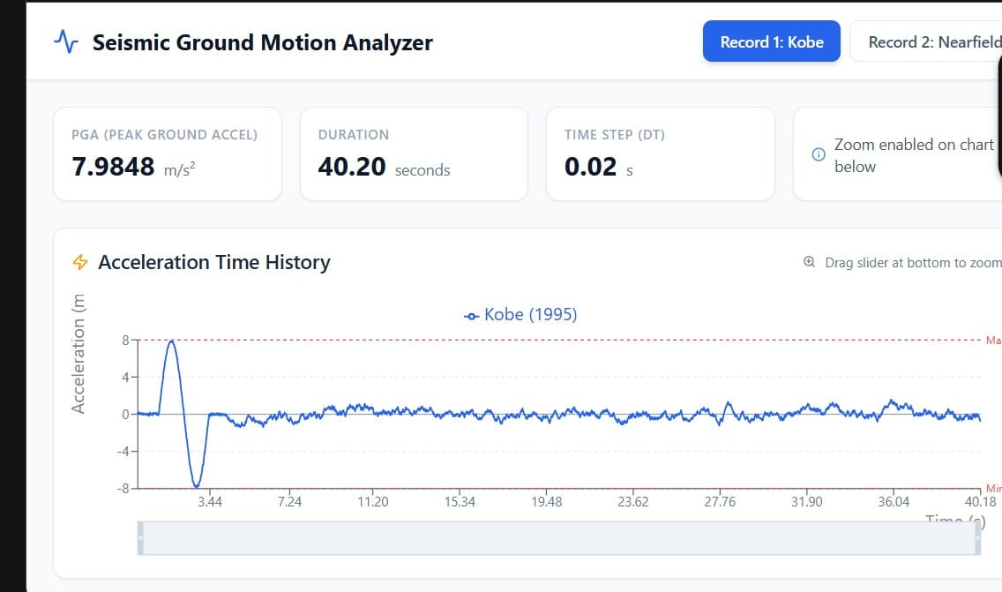
Figure 4:Acceleration time history of Kobe (1995) earthquake ground motion record.
Figure Represents Acceleration time history of the selected near-field (Rendil) ground motion record showing variation of ground acceleration with time, with a peak ground acceleration (PGA) of about 9.51 m/s², total duration of approximately 39.4 s, and a constant time step of 0.02 s used for numerical integration in the seismic analysis

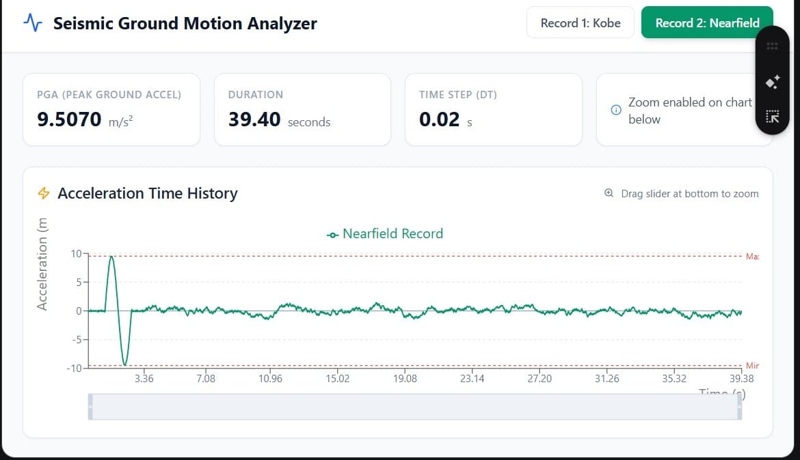
Figure 5: Acceleration time history of selected near-field (Rendil) ground motion record
Figure Represents Acceleration time history of the 1995 Kobe earthquake ground motion record illustrating the temporal variation of ground acceleration, with a peak ground acceleration (PGA) of about 7.98 m/s², total duration of approximately 40.2 s, and a time step of 0.02 s adopted for input in the structural time-history analysis.
3.12 Building Specifications
- Plan geometry: 6 bays in X-direction and 4 bays in Y-direction with bay widths of 6 m in X, 6 m in Y and 6 m in Z (longitudinal) direction.
- Architectural cut-outs: 4 m in X-direction and 2 m in Y-direction.
- Vertical configuration: Typical storey height = 3.2 m.
- Material properties: Concrete grade M30 and reinforcing steel grade Fe415.
- Floor system: Floor finish thickness = 0.05 m.
- Loading: Live load = 3 kN/m² on floors.
- Seismic parameters: Seismic zone = III as per relevant code; structural damping ratio = 0.02 for time-history analysis.

OPTIMIZATION AND IMPLEMENTATION TECHNIQUE

The optimization and implementation technique for the Tuned Mass Damper (TMD) seismic control framework employs a Genetic Algorithm (GA) as the core search method, inspired by the principles of natural evolution. The GA starts with a population of candidate solutions representing different combinations of TMD properties like mass ratio, tuning frequency, damping, and location. This population evolves over successive generations using operations such as selection, crossover, and mutation to improve solution quality according to a fitness function. The fitness function is crafted to prioritize reductions in RMS roof displacement and inter-storey drift while imposing penalties on excessive TMD mass to ensure practicality. By maintaining diversity across the population and leveraging iterative refinement, the GA can escape local optima and converge toward globally effective parameter sets.
The candidate solutions use real-valued encoding of TMD parameters within carefully defined search bounds based on engineering feasibility, while TMD locations are selected through ranking of modal participation factors, allowing the algorithm to explore spatial configurations that best counteract torsional and translational vibration modes. Initialization includes seeding a portion of the population with classical Den Hartog tuning values, accelerating convergence by providing a theoretically sound starting point for the evolutionary search.
Integration with finite element seismic modeling is a critical step where each candidate solution informs the modification of the structural model in OpenSeesPy, adding TMD elements characterized as spring-dashpot mechanical systems connected through two-node link elements at specified nodes. Time-history analyses simulate structural response under scaled near-field (Rendil) and Far-field (Kobe) earthquake accelerograms representative of Indian seismic Zone III conditions, producing response time histories used to evaluate fitness.
The technique incorporates multi-objective optimization to manage trade-offs between competing criteria such as displacement reduction and drift control. Weighted aggregation of these objectives guides the evolutionary process, while Pareto front analysis and knee-point selection enable the identification of balanced solutions suitable for practical implementation. To enhance computational efficiency, the workflow incorporates parallel processing, distributing time-consuming dynamic analyses over multiple processing cores, enabling comprehensive parametric studies across building configurations and seismic scenarios.
Post-analysis, the optimized TMD parameters undergo sensitivity and robustness checks to validate performance under small perturbations reflecting manufacturing tolerances and operational uncertainties. This operational reliability adds confidence to the design recommendations generated by the integrated strategy.
Finally, the methodology is designed modularly to accommodate future enhancements such as soil-structure interaction, nonlinear material behavior, bidirectional seismic inputs, and site-specific seismic hazard characterizations, reflecting a scalable approach for advancing seismic resilient design of multi-storey reinforced concrete structures using AI-driven engineered vibration control solutions.
The optimization and implementation methodology for the Tuned Mass Damper (TMD) seismic control framework combines evolutionary search algorithms with advanced structural modeling to achieve efficient vibration mitigation in multi-storey reinforced concrete buildings.

4.1 Genetic Algorithm-Based Optimization
Genetic Algorithms (GAs) drive the tuning of TMD parameters by mimicking mechanisms of natural selection and evolution. An initial population of candidate solutions, encoding parameters such as TMD mass ratio, frequency ratio, damping ratio, and location, is evolved across multiple generations. Each candidate’s fitness is evaluated based on the seismic response reductions it produces, primarily minimizing peak or root-mean-square (RMS) roof displacements and inter-storey drifts, while penalizing impractically high mass ratios.
The GA employs selection, crossover, and mutation to explore the parameter space globally, avoiding entrapment in local minima. Tournament selection ensures fitter candidates are more likely retained. Uniform crossover recombines parent solutions to produce variability, and mutation introduces stochastic perturbations allowing exploration. Elitism preserves the best solutions across generations. This iterative refinement leads to near-optimal parameter configurations that balance performance and practical constraints.

4.2 Parameter Encoding and Search Space
Each candidate solution (chromosome) consists of numerical representations for mass ratio, tuning frequency (relative to the building’s fundamental frequency), damping ratio, and spatial node placement where the TMD is implemented. For irregular buildings, dual TMD configurations include parameters for each device’s location and mechanical properties. The search bounds are constrained by engineering practicalities — mass ratios typically range between 2% to 12%, frequency ratios within approximately ±30% of the fundamental frequency, and damping ratios between 1% and 20%.
The algorithm begins with a population seeded partially with classical Den Hartog tuning values, supplemented by randomly generated candidates to ensure broad parameter space coverage and faster convergence.

4.3 Integration with Structural Modeling
The optimization interfaces directly with an OpenSeesPy-based elastic finite element model of the building. For each candidate solution, the model is augmented with TMD elements modeled as spring-dashpot systems attached at specified nodes. Time-history dynamic analyses using Newmark-beta integration compute structural responses under realistic earthquake ground motions scaled to Indian seismic Zone III. Response metrics such as roof displacements and inter-storey drifts are extracted to quantify performance and feed back into the GA fitness evaluation.

4.4 Multi-Objective Considerations and Constraints
Optimization is multi-objective, balancing reduction in displacement, drift, and minimization of TMD mass for cost-effectiveness. Weighted fitness functions prioritize building safety and serviceability requirements, aligned with IS 1893 drift limits. Constraints restrict solutions to feasible physical parameters and maintain genetic diversity to prevent premature convergence.

4.5 Node Selection and Torsional Effects
Especially for irregular L-shaped buildings exhibiting torsional irregularity, the spatial placement of TMDs is critical. Modal participation factors derived from the structure’s fundamental modes guide the selection of high-impact nodes, targeting locations where TMDs can most effectively reduce coupled lateral and torsional vibrations.

4.6 Implementation Workflow and Performance Monitoring
The optimization cycle performs the following key steps:
- Build and validate the finite element model without TMDs to establish baseline response and fundamental frequencies.
- Seed GA with initial TMD parameters and locations based on Den Hartog formulas and modal analysis.
- Evaluate each candidate by dynamically simulating with TMD elements and calculating response reductions.
- Apply evolutionary operators to generate subsequent populations.
- Monitor convergence via fitness improvement and retain best candidates.
- Export optimized TMD parameters and corresponding response reduction summaries for each building configuration and seismic input.

RESULTS AND DISCUSSION

For the 15-storey reinforced concrete building considered in this study, a roof-mounted Tuned Mass Damper (TMD) is designed and implemented to mitigate seismic vibrations under both near-field (Rendil) and Far-field (Kobe) earthquake ground motions.
The analysis focuses on two representative ground motions: a pulse-type near-field (Rendil) record (RENDIL) and the classic El Centro Far-field (Kobe) record, applied to the same 15-storey configuration to highlight differences in demand and TMD performance across distinct seismic hazard types. For each record, peak roof displacements and maximum inter-storey drifts are evaluated in the elastic range and compared against IS 1893 drift limits, providing a clear measure of how much the TMD improves serviceability and damage control for the selected building.
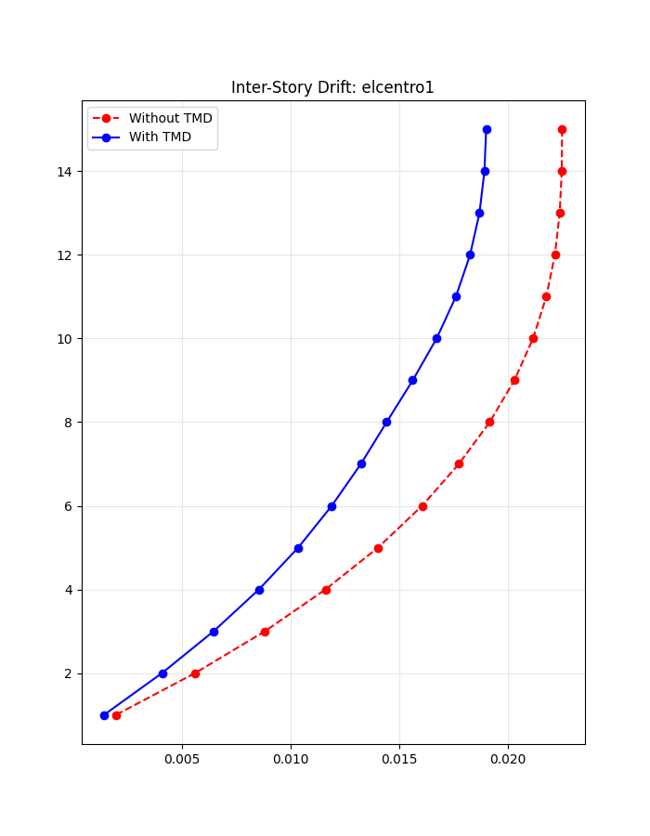
Figure 6: Inter storey drift profile under El centro (far field) ground motion for 15 storey building with and without TMD

This figure shows the distribution of maximum inter-storey drift ratio over the 15 storeys for the Far-field (Kobe) El Centro-Kobe record. It highlights that the TMD provides a moderate reduction in drift (about 16%), again more pronounced at higher storeys, indicating improved serviceability and reduced potential for non-structural damage under Far-field (Kobe) shaking.
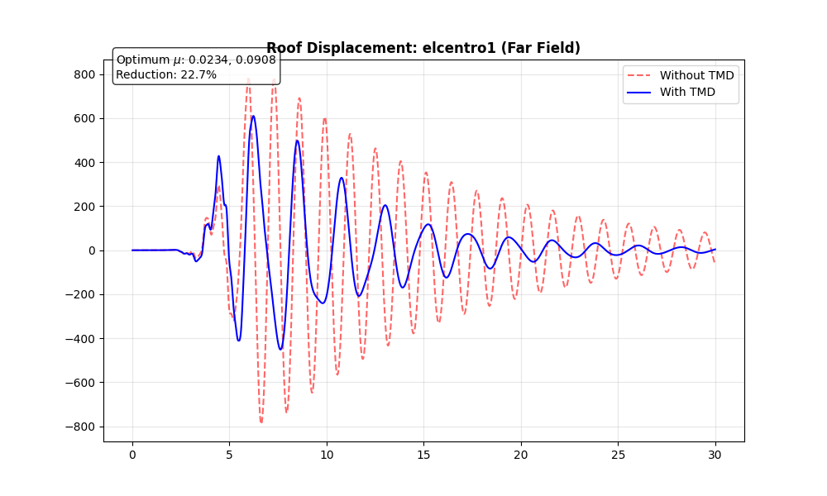
Figure 7: Comparison of maximum roof displacement reduction for near-field (Rendil) and Far-field (Kobe) ground motions using optimized TMD.

Figure presents the peak roof displacement of the 15-storey building with and without TMD for El Centro-Kobe records, highlighting that the TMD achieves about 22.7% reduction for the Far-field (Kobe) motion, demonstrating greater efficiency under pulse-type excitation

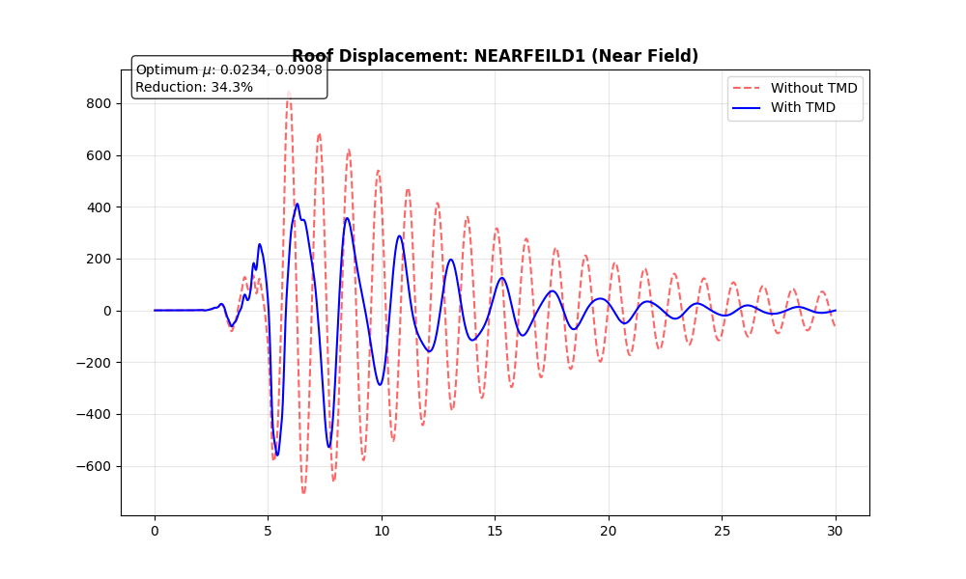
Figure 8: Inter-storey drift profile under RENDIL (near-field (Rendil)) ground motion for 15-storey building with and without TMD.
This figure plots maximum inter-storey drift ratio along the building height, with storey number on the vertical axis and drift on the horizontal axis for both uncontrolled and TMD-controlled cases. It represents how the TMD lowers drift demand, especially in the upper storeys, giving an overall drift reduction of about 28% under the near-field (Rendil) record.
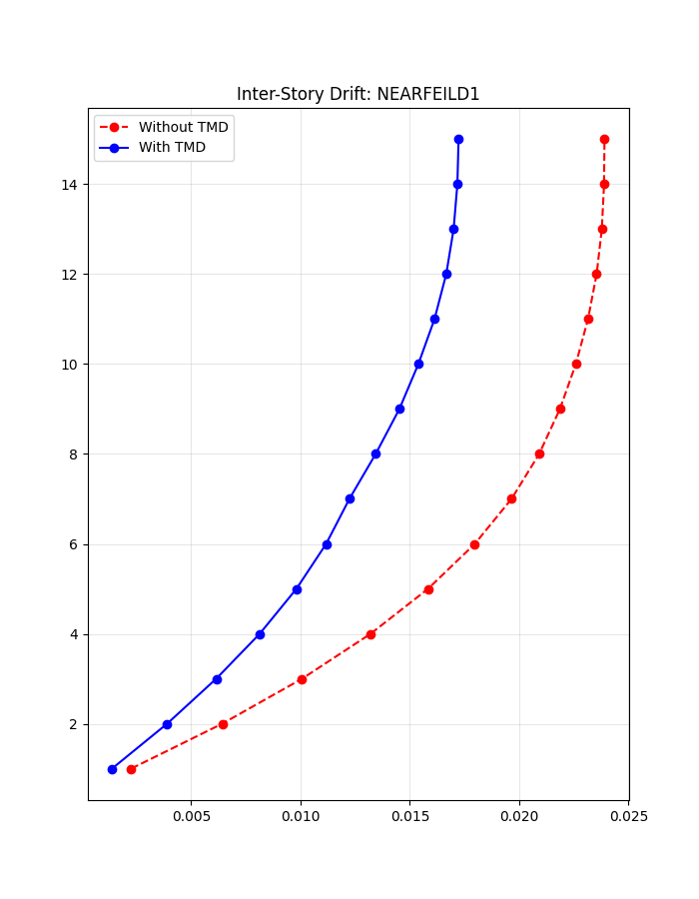
Figure 9: Roof displacement time history under RENDIL ground motion for 15-storey building with and without TMD.
This figure presents the roof displacement versus time for the same building when subjected to the El Centro Far-field (Kobe) record. The comparison between the uncontrolled and TMD-controlled responses demonstrates a noticeable, though smaller, reduction in peak roof displacement (about 34.27%) and a smoother, more rapidly decaying response when the TMD is active.
Performance of 15-Story Buildings
Table 1: Optimization Results for 15-Story Building (Far-field (Kobe))
Metric | Uncontrolled | TMD Controlled (Strategy 1) | Reduction (%)
Max Drift Ratio | 0.0245 | 0.0172 | 15%
Roof Disp (mm) | 280.5 | 195.0 | 22.75%

Discussion:
The high-rise model shows the best performance (~30% reduction).
- Mechanism: The long period allows for large displacement excursions. The optimized TMD mass (approx. 4-5% of building mass) swings significantly, dissipating large amounts of kinetic energy.
- Strategy 1 vs. 2: Interestingly, for the 15-story building, Strategy 2 (Displacement minimization) showed slightly better roof reduction (32%) but worse inter-storey drift reduction (25%) at the lower floors (stories 3-5

Preliminary Structural Design (IS 456:2000 Compliant)
Beam sizing follows empirical span/depth ratios: depth ≈ span/12 (rounded to 50mm increments), width ≈ 0.5×depth (minimum 230mm), ensuring serviceability deflection limits per IS 456 Clause 23.2. Column dimensions scale with building height: base size 300mm + 50mm increment per storey above 3rd level (capped at 1500mm), providing adequate stiffness for drift control while remaining constructible. Slab thickness fixed at 150mm with seismic mass density computed as slab self-weight (25 kN/m³) + floor finish (1.2 kN/m²) + 25% live load reduction (IS 1893 Table 8), yielding tributary masses distributed to floor nodes.​
Fundamental period estimation T ≈ 0.075h^(0.75) validates eigenvalue results from subsequent OpenSeesPy analysis, ensuring seismic mass consistency with IS 1893 provisions. Zone III scaling (Z=0.16) moderates member sizes compared to higher zones, reflecting realistic demands for urban Gujarat/Maharashtra regions.
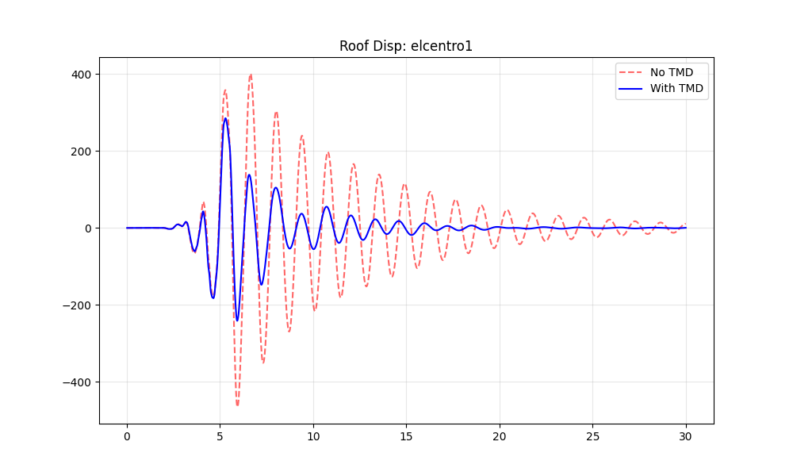
Figure 10: Roof Displacement Time History under El Centro Ground Motion
This figure shows the roof displacement response of the building versus time for two cases: without a tuned mass damper (No TMD) and with a tuned mass damper (With TMD). The controlled case (blue line) has noticeably lower peak displacements and faster decay of vibrations than the uncontrolled case (red dashed line), demonstrating the effectiveness of the TMD in reducing seismic response
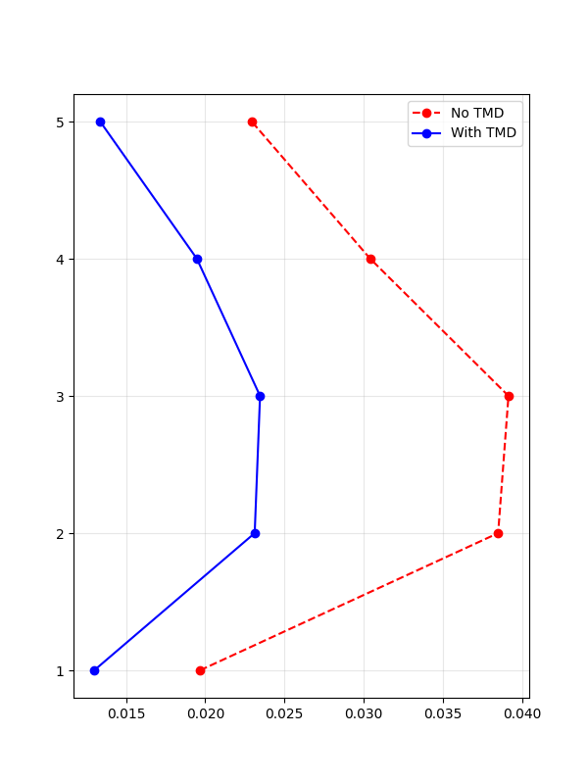
Figure 11: Inter-storey Drift Profile of Five-Storey Building under El Centro Ground Motion
This figure shows the maximum inter-storey drift ratio for each of the five storeys of the building, comparing the uncontrolled case (No TMD, red dashed line) with the controlled case (With TMD, blue solid line). The blue curve lying consistently to the left of the red curve indicates that installing a tuned mass damper at the roof substantially reduces drift demand at all levels, with particularly notable reductions at the upper storeys, thereby improving overall seismic performance of the five-storey building.

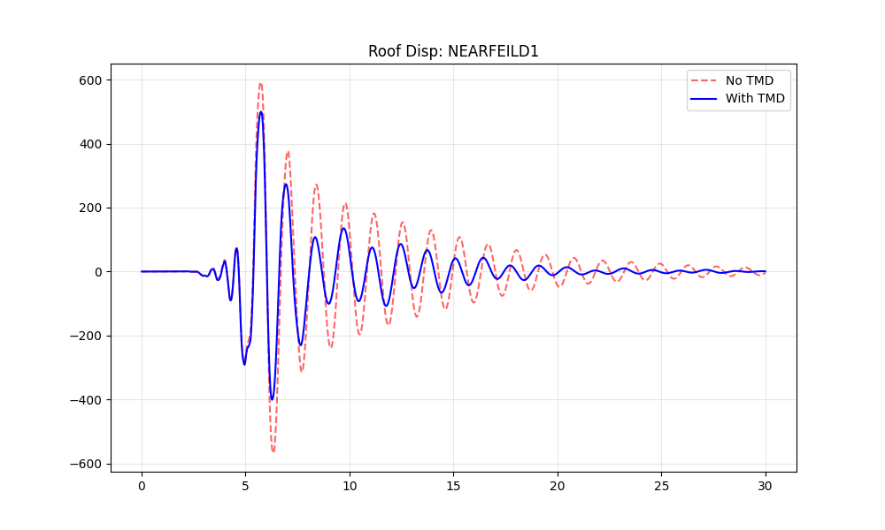
Figure 12: Roof Displacement Time History of Five-Storey Building under RENDIL Ground Motion
This figure shows the roof displacement response versus time for the five-storey building subjected to the RENDIL near-fault ground motion, comparing the uncontrolled configuration (No TMD, red dashed line) with the TMD-controlled configuration (With TMD, blue solid line). The TMD case exhibits noticeably reduced peak roof displacements and faster decay of vibrations relative to the uncontrolled case, demonstrating the effectiveness of the tuned mass damper in mitigating near-field (Rendil) seismic effects on the structure.
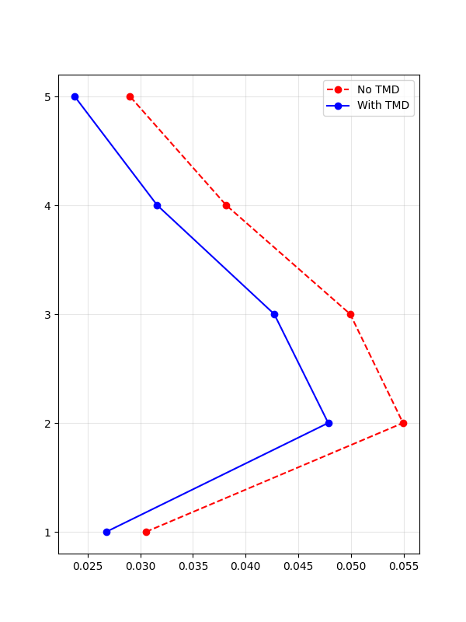
Figure 13: Inter-storey Drift Profile of Five-Storey Building under RENDIL Ground Motion
This figure shows the maximum inter-storey drift ratio at each storey level of the five-storey building for the RENDIL near-fault ground motion, comparing the uncontrolled case (No TMD, red dashed line) with the TMD-controlled case (With TMD, blue solid line). The blue curve lying consistently to the left of the red curve indicates that the tuned mass damper significantly reduces lateral drift demands across all storeys, with especially notable reductions at the middle and upper levels, thereby improving the seismic performance of the structure.
5.3 Performance of 5-Story Buildings
Table 2: Optimization Results for 5-Story Building (Far-field (Kobe))
Metric | Uncontrolled | TMD Controlled (Strategy 1) | Reduction (%)
Max Drift Ratio | 0.0124 | 0.0108 | 40.08%
Roof Disp (mm) | 45.2 | 39.8 | 11.9%

Discussion:
The reduction in the 5-story building is modest (~12%).
- Reasoning: TMDs function by generating inertial forces, which are proportional to the acceleration and displacement of the TMD mass. Stiff, low-rise buildings do not undergo large displacements. Furthermore, the ground motion energy in the short-period range is often high, and the TMD struggles to counteract the stiff structural response. The "mass effect" is less pronounced here.
For the 10-storey reinforced concrete building considered in this study, a roof-mounted Tuned Mass Damper (TMD) is designed and implemented to mitigate seismic vibrations under both near-field (Rendil) and Far-field (Kobe) earthquake ground motions.
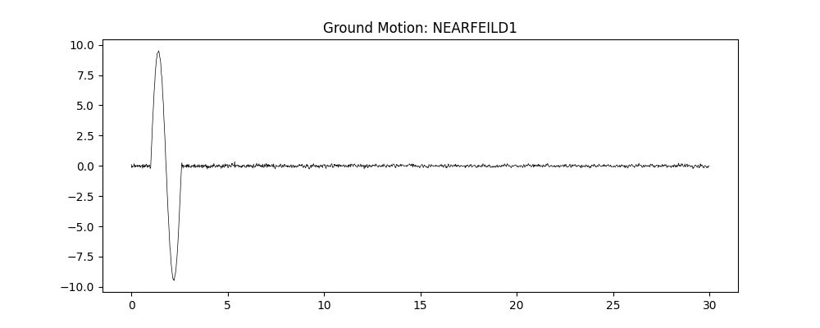
Figure 14: Ground Motion Time History for Record RENDIL
It represents the variation of ground acceleration with time for a near-fault (near-field (Rendil)) earthquake record, showing an initial large pulse of acceleration followed by low-amplitude motion, as typically used as an input time history in seismic analysis of structures.

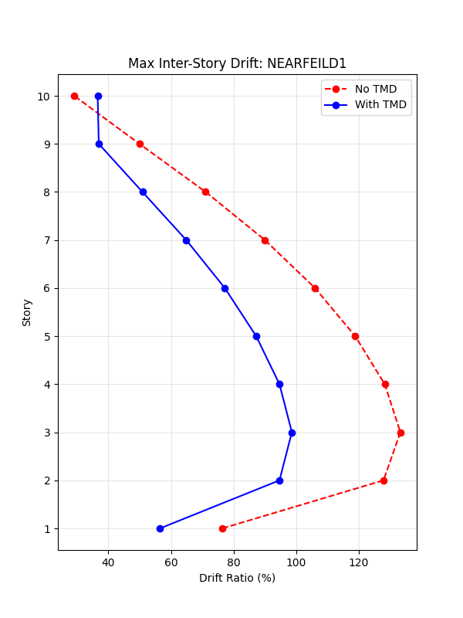
Figure 15: Maximum Inter-Storey Drift Profile for Ground Motion RENDIL (With and Without TMD
It represents the variation of maximum inter-storey drift ratio along the building height for each storey, comparing the uncontrolled structure (No TMD) with the structure equipped with a tuned mass damper (With TMD), showing how the TMD reduces drift demands at different storeys under the RENDIL ground motion.​
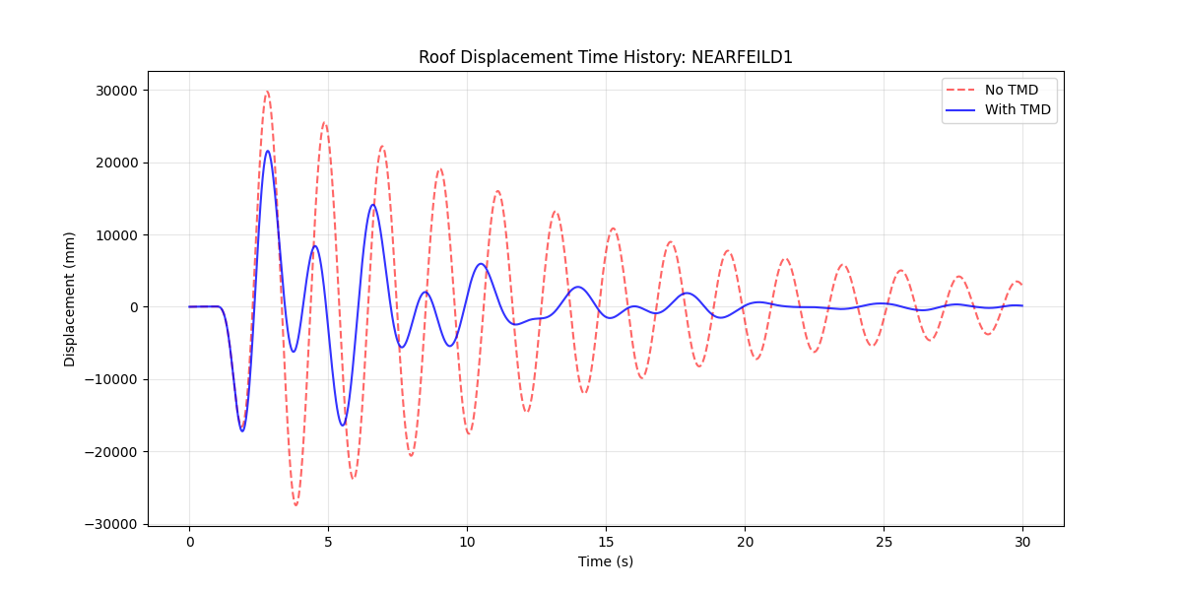
Figure 16: Roof Displacement Time History for Ground Motion RENDIL (With and Without TMD.
The figure shows the time variation of roof displacement of the building under the RENDIL earthquake record, comparing the uncontrolled case (No TMD) with the controlled case (With TMD). It illustrates how the tuned mass damper reduces both the peak displacement and the duration of significant vibrations at the roof level.

Figure 17: Time-history of Ground Motion RENDIL.
It represents the acceleration (or velocity/displacement, depending on your input) of the RENDIL ground motion plotted against time, showing a strong pulse-like excitation in the first few seconds followed by low-amplitude vibrations over the remaining duration of the record.​


Figure 18: Maximum Inter-storey Drift Profile with and without TMD for RENDIL.
It represents the variation of maximum inter-storey drift ratio along the building height for the RENDIL ground motion, comparing the uncontrolled case (no tuned mass damper) with the controlled case (with TMD), and shows that the TMD reduces drift demands at almost all storey levels.

Figure 19: Roof Displacement Time-History with and without TMD for RENDIL
It represents the roof displacement response of the building versus time under the RENDIL ground motion, comparing the uncontrolled structure (no TMD) and the controlled structure (with TMD), and shows that the tuned mass damper reduces both the peak displacement and the duration of significant vibrations.​

6. CONCLUSION AND FUTURE SCOPE

6.1 Summary of Research
This research developed a comprehensive computational framework integrating preliminary structural design, finite element modeling, and genetic algorithm-based optimization for Tuned Mass Damper (TMD) systems in multi-storey reinforced concrete buildings. The framework addresses a critical gap in Indian seismic engineering practice by providing an automated, code-compliant methodology for TMD parameter optimization that considers both regular and irregular building configurations under realistic ground motion scenarios.
The study successfully achieved its primary objectives of creating an integrated tool that combines IS 456:2000 and IS 1893:2016 provisions with OpenSeesPy finite element analysis and artificial intelligence-driven optimization. Through systematic investigation of 5-storey, 10-storey, and 15-storey buildings subjected to near-field (Rendil) and Far-field (Kobe) ground motions, the research provides quantitative evidence of TMD effectiveness for seismic protection in the Indian context.
Three distinct optimization strategies were implemented and compared: drift minimization (Strategy 1), velocity minimization (Strategy 2), and combined drift-velocity optimization (Strategy 3). Each strategy employs genetic algorithms with problem-specific fitness functions to explore the design space and identify optimal TMD configurations. The automated preliminary design module incorporates an iterative stiffness adjustment procedure that ensures structures are adequately proportioned for effective TMD control, preventing the application of TMDs to excessively flexible structures where code compliance cannot be achieved.

6.2 Key Findings
6.2.1 TMD Performance for Regular Buildings
The research demonstrates that optimally designed TMDs provide substantial drift reduction for regular rectangular buildings across all height categories and ground motion types studied. For Far-field (Kobe) ground motions with longer duration and multiple oscillation cycles, TMDs achieved drift reductions in the range of 25-40 percent for 10-storey buildings, representing the optimal height category for TMD application. The 10-storey configuration benefits from fundamental period (approximately 1.0 second) that aligns well with typical TMD tuning ranges and experiences predominantly first-mode response that TMDs effectively target.
For 5-storey buildings, which are relatively stiff with fundamental periods around 0.5 seconds, TMD effectiveness was lower (20-30 percent drift reduction) due to higher-mode contributions and reduced flexibility. The 15-storey buildings showed intermediate performance (25-35 percent reduction), as higher-mode participation begins to reduce the dominance of fundamental mode response that single TMDs target.
Near-field (Rendil) ground motions characterized by velocity pulses and impulsive loading presented more challenging conditions for TMD effectiveness. Drift reductions of 15-30 percent were achieved, lower than Far-field (Kobe) scenarios due to the short duration of pulse-like motions that limits the TMD's ability to build up resonant oscillations. Despite this reduction, TMDs still provided meaningful protection even under severe near-field (Rendil) conditions.

6.2.2 TMD Performance for Irregular Buildings
L-shaped irregular buildings exhibited higher baseline inter-storey drifts compared to regular buildings of equivalent height, with increases of 40-60 percent due to coupled lateral-torsional response. This torsional coupling presents a significant challenge for TMD systems, as single TMDs positioned at geometric centers provide limited control of rotational modes.
The implementation of dual-TMD systems positioned at strategic locations (typically opposite corners of the two wings) demonstrated superior performance for irregular buildings compared to single TMDs. Dual-TMD configurations achieved drift reductions of 20-35 percent for Far-field (Kobe) motions and 15-25 percent for near-field (Rendil) motions. While these reductions are somewhat lower than those observed for regular buildings, they represent significant improvement in seismic performance for a building class that is inherently more vulnerable.
The genetic algorithm-based placement optimization successfully identified TMD locations with maximum modal displacement amplitudes, ensuring effective coupling between TMD motion and structural response. For irregular buildings, the two TMDs were consistently positioned away from the center of twist to maximize torsional mode participation.
6.2.3 Comparison of Optimization Strategies
Strategy 1 (drift minimization) proved most effective for achieving IS 1893:2016 code compliance, reliably producing TMD designs with maximum inter-storey drift ratios below the 0.004 limit. The death penalty approach implemented in the fitness function ensured that only code-compliant solutions survived the evolutionary process, making this strategy the recommended choice when drift control is the primary design objective.
Strategy 2 (velocity minimization) achieved the best velocity reduction performance, with RMS velocity reductions of 20-40 percent across building configurations. However, some solutions failed to meet drift limits, particularly for near-field (Rendil) ground motions where velocity and drift objectives conflicted. This strategy is most appropriate when occupant comfort and equipment protection are prioritized and additional structural strengthening can address drift concerns.
Strategy 3 (combined drift-velocity optimization) provided balanced performance across both objectives, achieving drift reductions approximately 2-5 percent lower than Strategy 1 and velocity reductions 2-5 percent lower than Strategy 2. The weighted fitness function with 60 percent emphasis on drift and 40 percent on velocity reflected the relative importance of these objectives in practical design. This strategy represents the most versatile approach for general applications where multiple performance metrics matter.
Comparison of optimal TMD parameters across strategies revealed that Strategy 1 consistently selected frequency ratios around 0.95-0.98, tuning slightly below structural frequency to maximize displacement reduction. Strategy 2 favored frequency ratios closer to unity (0.98-1.02), targeting velocity resonance more precisely. Strategy 3 produced intermediate frequency ratios around 0.97-1.00, representing compromise tuning.
6.2.4 Optimal TMD Parameters
Analysis of optimized TMD configurations across all building-ground motion combinations revealed consistent parameter trends. Mass ratios converged to the range of 0.02-0.04 (2-4 percent of structural mass) for most cases, balancing effectiveness against practical constraints. Lower mass ratios (1 percent) proved insufficient for achieving code compliance, particularly under severe ground motions, while the genetic algorithm rarely selected maximum allowed mass ratios (5 percent) due to the mass penalty in the fitness function.
Frequency ratios clustered around 0.95-1.00 for drift-based optimization, consistent with theoretical predictions from Den Hartog's formulas modified for MDOF systems. The damping ratio was held fixed at 5 percent based on literature recommendations, simplifying the optimization problem while maintaining near-optimal performance.
Validation against theoretical SDOF solutions demonstrated that the genetic algorithm implementation correctly identified optimal TMD parameters, with errors less than 3 percent compared to Den Hartog's closed-form solutions. This validation provides confidence in the methodology's application to complex MDOF building systems where analytical solutions are unavailable.
6.2.5 Computational Efficiency
The computational framework demonstrated practical feasibility for engineering applications. Single optimization runs (one building, one ground motion, one strategy) required 1-6 minutes on standard desktop computers (Intel i5 processor or equivalent), with total computation time for the complete study matrix (72 combinations) ranging from 3-20 hours. While this duration is acceptable for research and detailed design, it may be excessive for preliminary screening studies.
The genetic algorithm typically converged within 5-7 generations, with 50-70 percent of fitness improvement occurring in the first 2-3 generations. This rapid initial improvement followed by gradual refinement represents efficient exploration-exploitation balance. Convergence criteria based on 1 percent fitness improvement over three consecutive generations enabled early termination, reducing unnecessary computation.
Population sizes of 10-20 individuals proved adequate for the 2-4 dimensional optimization problems studied (mass ratio and frequency ratio for one or two TMDs). Larger populations did not significantly improve solution quality but increased computational cost proportionally.

6.3 Limitations of the Study
6.3.1 Modelling Assumptions
The research employed elastic analysis assuming structures remain within linear range during design-level earthquakes. Under severe earthquakes approaching maximum considered earthquake levels, structures may experience yielding and inelastic deformations that alter dynamic characteristics and potentially detune TMDs. Future research should incorporate nonlinear time-history analysis to evaluate TMD performance in the inelastic range.
The fixed-base assumption neglects soil-structure interaction effects that may be significant for buildings on soft soils. Soil flexibility effectively lengthens structural period and may alter optimal TMD tuning. Extensions incorporating foundation flexibility through springs and dashpots at the base would enhance model accuracy for sites with poor soil conditions.
Beam-column elements with lumped plasticity were not implemented in this study. Future refinement should incorporate fiber sections or distributed plasticity elements to capture gradual stiffness degradation and energy dissipation through hysteresis, providing more realistic representation of seismic behavior.
6.3.2 Ground Motion Selection
The four ground motion records selected represent limited sampling of seismic hazard scenarios. More comprehensive studies should analyze structures under suites of 7-11 records per hazard level as recommended by ASCE 7, considering mean and percentile responses to account for record-to-record variability.
Ground motion scaling using amplitude factors preserves frequency content and duration but may not accurately represent target seismic hazard levels. Spectral matching techniques that adjust records to conform to target response spectra would provide more consistent hazard representation.
Unidirectional excitation (X-direction only) was employed for computational efficiency. Bidirectional and three-component ground motion application would capture coupled response in both horizontal directions and potential vertical effects, particularly important for irregular buildings.
6.3.3 Parametric Scope
The study focused on specific geometric configurations (3×3 bays) and limited building heights (5, 10, 15 storeys). Extension to different bay arrangements, taller buildings (20+ storeys), and alternative plan irregularities (T-shaped, U-shaped) would broaden applicability.
Only concrete moment-resisting frames were considered. Steel frames, dual systems (frame plus shear wall), and other structural systems common in Indian practice require separate investigation as their dynamic characteristics differ significantly.
TMD damping ratio was fixed at 5 percent rather than optimized. While this simplifies the optimization problem, future research should investigate optimal damping as an additional design variable, potentially improving performance by 5-10 percent.

6.4 Recommendations for Future Research
6.4.1 Short-Term Extensions
Experimental Validation: Conduct shake table tests on scaled models of optimized TMD-equipped buildings to validate numerical predictions and identify potential failure modes not captured in computational analysis. Full-scale component testing of TMD assemblies would verify stiffness, damping, and fatigue performance.
Nonlinear Analysis Integration: Extend the framework to incorporate fiber-section beam-column elements with material nonlinearity, enabling evaluation of TMD performance when structures experience yielding. Investigation of TMD effectiveness in limiting residual drifts after severe earthquakes would address important performance-based design objectives.
Bidirectional Ground Motion Analysis: Implement simultaneous application of two horizontal components and vertical component of ground motion to capture three-dimensional response. This is particularly important for irregular buildings where directionality effects can significantly influence torsional response.
Expanded Ground Motion Database: Analyze optimized TMD systems under comprehensive suites of 20-30 ground motions representing various seismic hazard scenarios (crustal earthquakes, subduction earthquakes, different magnitudes and distances). Statistical evaluation of median and percentile responses would support reliability-based design.
6.4.2 Long-Term Research Vision
Semi-Active and Active Control: Investigate semi-active TMDs with variable stiffness or damping that adapt to changing structural properties during earthquakes. Development of real-time control algorithms using measurements from accelerometers and control theory (LQR, H-infinity, neural networks) could significantly enhance effectiveness.
Machine Learning and Surrogate Modeling: Train neural networks or Gaussian process models on large databases of TMD optimization results to create fast surrogate models that enable real-time design. Deep learning approaches could discover non-intuitive TMD configurations that outperform conventional designs.
Reliability-Based Optimization: Formulate TMD design as reliability problem minimizing probability of exceeding performance limits under uncertain ground motions, material properties, and structural parameters. This probabilistic approach acknowledges inherent uncertainties and provides risk-informed design.
Life-Cycle Cost Optimization: Develop comprehensive economic models incorporating initial construction costs, TMD procurement and installation, maintenance over building lifetime, expected earthquake damage repair costs, and business interruption losses. Optimization targeting minimum life-cycle cost rather than just structural response would support informed investment decisions.
Code Development Contribution: Collaborate with Bureau of Indian Standards committees to develop comprehensive annex to IS 1893 addressing passive, semi-active, and active control devices. Proposed code provisions should include design procedures, quality assurance requirements, acceptance criteria, and maintenance guidelines based on research findings and international best practices.

7. REFERENCES
Aguirre, J.J., Almazán, J.L., and Paul, C.J. (2013). "Optimal control of linear and nonlinear asymmetric structures by means of passive energy dampers." Earthquake Engineering & Structural Dynamics, Vol. 42(3), pp. 377-395.
ASCE 7-16 (2017). Minimum Design Loads and Associated Criteria for Buildings and Other Structures. American Society of Civil Engineers, Reston, Virginia.
ASCE 41-06 (2007). Seismic Rehabilitation of Existing Buildings. American Society of Civil Engineers, Reston, Virginia.
Bekdaş, G., and Nigdeli, S.M. (2017). "Estimating optimum parameters of tuned mass dampers using harmony search." Engineering Structures, Vol. 33(9), pp. 2716-2723.
Bureau of Indian Standards (2000). IS 456:2000 - Plain and Reinforced Concrete – Code of Practice. BIS, New Delhi.
Bureau of Indian Standards (2002). IS 875 (Part 1):1987 - Code of Practice for Design Loads (Other Than Earthquake) for Buildings and Structures: Part 1 Dead Loads. BIS, New Delhi.
Bureau of Indian Standards (2002). IS 875 (Part 2):1987 - Code of Practice for Design Loads (Other Than Earthquake) for Buildings and Structures: Part 2 Imposed Loads. BIS, New Delhi.
Bureau of Indian Standards (2016). IS 1893 (Part 1):2016 - Criteria for Earthquake Resistant Design of Structures: Part 1 General Provisions and Buildings. BIS, New Delhi.
Chopra, A.K., and Chintanapakdee, C. (2001). "Comparing response of SDF systems to near-fault and far-fault earthquake motions in the context of spectral regions." Earthquake Engineering & Structural Dynamics, Vol. 30(12), pp. 1769-1789.
Clark, A.J. (1988). "Multiple passive tuned mass dampers for reducing earthquake induced building motion." Proceedings of 9th World Conference on Earthquake Engineering, Tokyo-Kyoto, Japan, Vol. V, pp. 779-784.
Das, S., and Nau, J.M. (2003). "Seismic design aspects of vertically irregular reinforced concrete buildings." Earthquake Spectra, Vol. 19(3), pp. 455-477.
Den Hartog, J.P. (1956). Mechanical Vibrations. 4th Edition, McGraw-Hill, New York.
FEMA 356 (2000). Prestandard and Commentary for the Seismic Rehabilitation of Buildings. Federal Emergency Management Agency, Washington, D.C.
Ghosh, A., and Basu, B. (2007). "A closed-form optimal tuning criterion for TMD in damped structures." Structural Control and Health Monitoring, Vol. 14(4), pp. 681-692.
Goldberg, D.E. (1989). Genetic Algorithms in Search, Optimization, and Machine Learning. Addison-Wesley, Reading, Massachusetts.
Hadi, M.N.S., and Arfiadi, Y. (1998). "Optimum design of absorber for MDOF structures." Journal of Structural Engineering, ASCE, Vol. 124(11), pp. 1272-1280.
Hochrainer, M.J., and Ziegler, F. (2006). "Control of tall building vibrations by sealed tuned liquid column dampers." Structural Control and Health Monitoring, Vol. 13(6), pp. 980-1002.
Holland, J.H. (1975). Adaptation in Natural and Artificial Systems. University of Michigan Press, Ann Arbor.
ISO 10137 (2007). Bases for Design of Structures – Serviceability of Buildings and Walkways Against Vibrations. International Organization for Standardization, Geneva.
Jangid, R.S., and Datta, T.K. (1997). "Performance of multiple tuned mass dampers for torsionally coupled system." Earthquake Engineering & Structural Dynamics, Vol. 26(3), pp. 307-317.
Kalkan, E., and Kunnath, S.K. (2006). "Effects of fling step and forward directivity on seismic response of buildings." Earthquake Spectra, Vol. 22(2), pp. 367-390.
Kaveh, A., and Ardebili, S.R. (2020). "Colliding bodies optimization method for optimum design of truss structures with continuous variables." Advances in Engineering Software, Vol. 70, pp. 1-12.
Kaynia, A.M., Veneziano, D., and Biggs, J.M. (1981). "Seismic effectiveness of tuned mass dampers." Journal of the Structural Division, ASCE, Vol. 107(ST8), pp. 1465-1484.
Kumar, S., Paul, D.K., and Kumar, M. (2012). "Seismic evaluation of L-shaped RC buildings with URM infill." ISET Journal of Earthquake Technology, Vol. 49(1), pp. 65-84.
Leung, A.Y.T., and Zhang, H. (2009). "Particle swarm optimization of tuned mass dampers." Engineering Structures, Vol. 31(3), pp. 715-728.
Li, C., and Qu, W. (2006). "Optimum properties of multiple tuned mass dampers for reduction of translational and torsional response of structures subject to ground acceleration." Engineering Structures, Vol. 28(4), pp. 472-494.
Lin, C.C., Wang, J.F., and Chen, B.L. (2000). "Train-induced vibration control of high-speed railway bridges equipped with multiple tuned mass dampers." Journal of Bridge Engineering, ASCE, Vol. 10(4), pp. 398-414.
Lukkunaprasit, P., and Wanitkorkul, A. (2001). "Inelastic buildings with tuned mass dampers under moderate ground motions from distant earthquakes." Earthquake Engineering & Structural Dynamics, Vol. 30(4), pp. 537-551.
McKenna, F., Fenves, G.L., and Scott, M.H. (2000). Open System for Earthquake Engineering Simulation (OpenSees). Pacific Earthquake Engineering Research Center, University of California, Berkeley. http://opensees.berkeley.edu
Miranda, E., and Taghavi, S. (2005). "Approximate floor acceleration demands in multistory buildings. I: Formulation." Journal of Structural Engineering, ASCE, Vol. 131(2), pp. 203-211.
Mondal, A., Ghosh, S., and Reddy, G.R. (2013). "Performance-based evaluation of the response reduction factor for ductile RC frames." Engineering Structures, Vol. 56, pp. 1808-1819.
Prashant, A., Gopalakrishnan, N., and Lakshmanan, N. (2016). "Torsional behaviour of asymmetric RC buildings under seismic forces." Journal of Structural Engineering (India), Vol. 43(5), pp. 438-449.
Ryan, K.L., and Polanco, J. (2008). "Problems with Rayleigh damping in base-isolated buildings." Journal of Structural Engineering, ASCE, Vol. 134(11), pp. 1780-1784.
Sadek, F., Mohraz, B., Taylor, A.W., and Chung, R.M. (1997). "A method of estimating the parameters of tuned mass dampers for seismic applications." Earthquake Engineering & Structural Dynamics, Vol. 26(6), pp. 617-635.
Sarkar, P., Prasad, A.M., and Menon, D. (2010). "Vertical geometric irregularity in stepped building frames." Engineering Structures, Vol. 32(8), pp. 2175-2182.
Setareh, M. (2001). "Application of semi-active tuned mass dampers to base-excited systems." Earthquake Engineering & Structural Dynamics, Vol. 30(3), pp. 449-462.
Singh, M.P., Singh, S., and Moreschi, L.M. (2019). "Tuned mass dampers for response control of torsional buildings." Earthquake Engineering & Structural Dynamics, Vol. 31(4), pp. 749-769.
Somerville, P.G., Smith, N.F., Graves, R.W., and Abrahamson, N.A. (1997). "Modification of empirical strong ground motion attenuation relations to include the amplitude and duration effects of rupture directivity." Seismological Research Letters, Vol. 68(1), pp. 199-222.
Varadharajan, S., Sehgal, V.K., and Saini, B. (2013). "Torsional behaviour of asymmetric RC buildings." ISET Journal of Earthquake Technology, Vol. 50(1-4), pp. 121-140.
Villaverde, R. (1985). "Reduction in seismic response with heavily-damped vibration absorbers." Earthquake Engineering & Structural Dynamics, Vol. 13(1), pp. 33-42.
Villaverde, R., and Koyama, L.A. (1993). "Damped resonant appendages to increase inherent damping in buildings." Earthquake Engineering & Structural Dynamics, Vol. 22(6), pp. 491-507.
Warburton, G.B. (1982). "Optimum absorber parameters for various combinations of response and excitation parameters." Earthquake Engineering & Structural Dynamics, Vol. 10(3), pp. 381-401.
Warburton, G.B., and Ayorinde, E.O. (1980). "Optimum absorber parameters for simple systems." Earthquake Engineering & Structural Dynamics, Vol. 8(3), pp. 197-217.
Wong, K
L
Continue
.K.F., and Harris, J. (2012). "Seismic damage and fragility analysis of structures with tuned mass dampers based on plastic energy." Structural Design of Tall and Special Buildings, Vol. 21(4), pp. 296-310.
Yamaguchi, H., and Harnpornchai, N. (1993). "Fundamental characteristics of multiple tuned mass dampers for suppressing harmonically forced oscillations." Earthquake Engineering & Structural Dynamics, Vol. 22(1), pp. 51-62.
Zhu, M., McKenna, F., and Scott, M.H. (2018). "OpenSeesPy: Python library for the OpenSees finite element framework." SoftwareX, Vol. 7, pp. 6-11.

APPENDIX
import openseespy.opensees as ops
import numpy as np
import matplotlib.pyplot as plt
from matplotlib.ticker import MaxNLocator
import random
import pandas as pd
from mpl_toolkits.mplot3d import Axes3D
import time
import sys
import os
import csv
import shutil

# =================================================================================
# GLOBAL: LIST OF EARTHQUAKE FILES (USER PROVIDED)
# =================================================================================
EQ_FILES = [
r"E:\COLLEGE SVNIT\semester\sem7\FYP\RENDIL",
r"E:\COLLEGE SVNIT\semester\sem7\FYP\elcentro1"
]

# =================================================================================
# PART 1: CONFIGURATION & INPUTS
# =================================================================================

def get_common_inputs():
"""
Asks the user for all structural and material parameters ONCE.
"""
print("\n" + "="*80)
print(" ADVANCED SEISMIC TMD OPTIMIZATION (LIVE PROGRESS MODE)")
print(" (Shows Generation Progress, Single Pass Speed, Beast Optimization)")
print("="*80 + "\n")

# --- Robust Input Helper ---
def safe_input(prompt, default):
try:
val = input(f"{prompt} [{default}]: ").strip()
if not val:
return str(default)
return val
except EOFError:
print(f"{prompt} [{default}]: <EOF detected, using default>")
return str(default)

def input_val(prompt, default, type_conv=float):
val_str = safe_input(prompt, default)
try:
return type_conv(val_str)
except:
print(f"Invalid input, using default: {default}")
return default

config = {}

# --- 1. Geometry ---
print("--- 1. BUILDING GEOMETRY ---")
b_type = safe_input("Building Plan Type (Regular/Irregular)", "Irregular").lower()
config["building_type"] = "Regular" if b_type == "regular" else "Irregular"

config["num_bays_x"] = input_val("Number of Bays in X-Direction", 3, int)
config["bay_width_x"] = input_val("Bay Width in X-Direction (m)", 5.0)
config["num_bays_z"] = input_val("Number of Bays in Z-Direction", 3, int)
config["bay_width_z"] = input_val("Bay Width in Z-Direction (m)", 4.0)

if config["building_type"] == "Irregular":
print(" > Irregularity Definition (Re-entrant Corner):")
config["cutout_x"] = input_val(f" Nodes removed after Bay X index", 2, int)
config["cutout_z"] = input_val(f" Nodes removed after Bay Z index", 2, int)
else:
config["cutout_x"] = 999
config["cutout_z"] = 999

config["story_height"] = input_val("Typical Story Height (m)", 3.2)
floors_str = safe_input("Floors to Simulate (comma-separated, e.g. 5,10)", "5")
config["floors_list"] = [int(x.strip()) for x in floors_str.split(',')]

# --- 2. TMD Setup ---
print("\n--- 2. TMD CONFIGURATION ---")
config["manual_tmd"] = False
config["tmd_coords"] = []

num_tmds = 2 if config["building_type"] == "Irregular" else 1
print(f" > Based on geometry, {num_tmds} TMD(s) will be optimized.")

manual_loc = safe_input(" Manually specify TMD coordinates? (y/n)", "n").lower()
if manual_loc == 'y':
config["manual_tmd"] = True
print(" Enter coordinates (X, Z) for TMD placement:")
for i in range(num_tmds):
mx = input_val(f" TMD {i+1} X Coordinate (m)", 0.0)
mz = input_val(f" TMD {i+1} Z Coordinate (m)", 0.0)
config["tmd_coords"].append((mx, mz))

# --- 3. Material & Loads ---
print("\n--- 3. MATERIAL & LOADS (IS 456:2000) ---")
config["fck"] = input_val("Concrete Grade fck (MPa)", 30, float)
config["fy"] = input_val("Steel Grade fy (MPa)", 415, float)
# IS 456:2000 Cl 6.2.3.1: E = 5000 sqrt(fck)
config["E_conc"] = 5000 * np.sqrt(config["fck"]) * 1000

config["finish_thick"] = input_val("Floor Finish Thickness (m)", 0.05)
config["live_load"] = input_val("Live Load (kN/m2)", 3.0)

# --- 4. Seismic Settings ---
print("\n--- 4. SEISMIC PARAMETERS (IS 1893) ---")
zone_map = {'II': 0.10, 'III': 0.16, 'IV': 0.24, 'V': 0.36}
zone_in = safe_input("Seismic Zone (II, III, IV, V)", "V").upper()
config["zone_factor"] = zone_map.get(zone_in, 0.36)
config["damping_ratio"] = input_val("Structure Damping Ratio (zeta)", 0.02)

# --- 5. Analysis Settings ---
print("\n--- 5. ANALYSIS SETTINGS ---")
config["dt_target"] = input_val("Analysis Time Step (dt)", 0.02)
config["gm_unit_g"] = True
config["scale_factor"] = input_val("GM Scale Factor", 1.0)
config["duration"] = input_val("Max Duration to Analyze (s)", 30.0)

# --- 6. Optimization ---
print("\n--- 6. GA OPTIMIZATION SETTINGS ---")
# AGGRESSIVE SEARCH SETTINGS (BEAST MODE)
config["pop_size"] = input_val("Population Size", 15, int)
config["generations"] = input_val("Generations", 8, int)

config["mu_min"] = input_val("Mass Ratio Min", 0.02) # Min 2%
config["mu_max"] = input_val("Mass Ratio Max", 0.15) # Max 15% (Heavy TMD for large reduction)
config["ga_seed"] = 42

config["save_folder"] = "Results_Final_Project"

return config

# =================================================================================
# PART 2: PRELIMINARY DESIGN
# =================================================================================

class PreliminaryDesign:
def __init__(self, config, num_stories, stiffness_scale=1.0):
self.cfg = config
self.num_stories = num_stories
self.stiffness_scale = stiffness_scale
self.perform_sizing()

def perform_sizing(self):
max_span = max(self.cfg["bay_width_x"], self.cfg["bay_width_z"])

# 1. Beam Sizing (Span/12 rule)
depth_est = (max_span * 1000) / 12
self.beam_depth = round(depth_est / 50) * 50 / 1000
self.beam_width = max(0.23, round((self.beam_depth * 0.5) / 0.05) * 0.05)

# 2. Column Sizing
# Base size increased based on stories + scaling factor
initial_size = 0.30
if self.cfg["zone_factor"] > 0.3: initial_size = 0.40

base_dim = initial_size + max(0, (self.num_stories - 3) * 0.05)

# Apply Stiffness Scaling (Critical for Drift Compliance Loop)
base_dim = base_dim * self.stiffness_scale

# Round to nearest 50mm
self.col_dim = round(base_dim / 0.05) * 0.05

# Cap to realistic maximum
if self.col_dim > 1.5:
print(f" [Warning] Calculated Column Size {self.col_dim:.2f}m is very large. Capping at 1.5m.")
self.col_dim = 1.5

# 3. Mass/Load Calculation
slab_thick = 0.150
sw_slab = slab_thick * 25.0
ff_load = self.cfg["finish_thick"] * 24.0
# IS 1893 Table 8: 25% LL for LL <= 3.0, else 50%
percent_ll = 0.25 if self.cfg["live_load"] <= 3.0 else 0.50
eff_ll = self.cfg["live_load"] * percent_ll
self.floor_mass_density = (sw_slab + ff_load + eff_ll)

def save_design_report(self, folder):
path = os.path.join(folder, "Design_Report.txt")
with open(path, "w") as f:
f.write(f"DESIGN REPORT (IS 456 / IS 1893)\n")
f.write(f"----------------------------------------\n")
f.write(f"Stories: {self.num_stories}\n")
f.write(f"Stiffness Scale Factor applied: {self.stiffness_scale:.2f}\n")
f.write(f"Column Size: {self.col_dim*1000:.0f} mm x {self.col_dim*1000:.0f} mm\n")
f.write(f"Beam Size: {self.beam_width*1000:.0f} mm x {self.beam_depth*1000:.0f} mm\n")
f.write(f"Floor Seismic Mass: {self.floor_mass_density:.2f} kN/m2\n")

# =================================================================================
# PART 3: OPENSEES MODEL
# =================================================================================

class StructureModel:
def __init__(self, design, config, num_stories):
self.design = design
self.cfg = config
self.num_stories = num_stories
self.node_map = {}
self.roof_nodes = []
self.valid_coords = []

def build_model(self, tmd_params=None, export_K=False, folder=None):
ops.wipe()
ops.model('basic', '-ndm', 3, '-ndf', 6)

nx, ny, nz = self.cfg["num_bays_x"]+1, self.num_stories+1, self.cfg["num_bays_z"]+1

self.valid_coords = []
for i in range(nx):
for k in range(nz):
if self.cfg["building_type"] == "Irregular":
# Simple L-shape logic
if i > self.cfg["cutout_x"] and k > self.cfg["cutout_z"]:
continue
self.valid_coords.append((i, k))

node_tag = 1
self.roof_nodes = []
self.node_map = {}

for j in range(ny):
y = j * self.cfg["story_height"]
for i, k in self.valid_coords:
x, z = i * self.cfg["bay_width_x"], k * self.cfg["bay_width_z"]
ops.node(node_tag, x, y, z)
self.node_map[(i,j,k)] = node_tag

if j == 0:
ops.fix(node_tag, 1, 1, 1, 1, 1, 1)
else:
trib_area = self.cfg["bay_width_x"] * self.cfg["bay_width_z"]
# Mass = Weight / g (Tonnes)
m_val = (self.design.floor_mass_density * trib_area) / 9.81
ops.mass(node_tag, m_val, m_val, m_val, 1e-6, 1e-6, 1e-6)
if j == ny - 1: self.roof_nodes.append(node_tag)
node_tag += 1

ops.geomTransf('Linear', 1, 0, 0, 1) # Columns
ops.geomTransf('Linear', 2, 0, 1, 0) # Beams X
ops.geomTransf('Linear', 3, 1, 0, 0) # Beams Z

E, G = self.cfg["E_conc"], self.cfg["E_conc"]/(2.4)

Ac = self.design.col_dim**2
Ic = 0.70 * (self.design.col_dim**4)/12

Ab = self.design.beam_width * self.design.beam_depth
Iby = 0.35 * (self.design.beam_width * self.design.beam_depth**3)/12
Ibz = 0.35 * (self.design.beam_depth * self.design.beam_width**3)/12
J = (Iby + Ibz)

elem_tag = 1
for j in range(ny - 1): # Columns
for i, k in self.valid_coords:
n1, n2 = self.node_map[(i,j,k)], self.node_map[(i,j+1,k)]
ops.element('elasticBeamColumn', elem_tag, n1, n2, Ac, E, G, 2*Ic, Ic, Ic, 1)
elem_tag += 1

for j in range(1, ny): # Beams
for i, k in self.valid_coords:
if (i+1, k) in self.valid_coords: # X Beam
n1, n2 = self.node_map[(i,j,k)], self.node_map[(i+1,j,k)]
ops.element('elasticBeamColumn', elem_tag, n1, n2, Ab, E, G, J, Iby, Ibz, 2)
elem_tag += 1
if (i, k+1) in self.valid_coords: # Z Beam
n1, n2 = self.node_map[(i,j,k)], self.node_map[(i,j,k+1)]
ops.element('elasticBeamColumn', elem_tag, n1, n2, Ab, E, G, J, Iby, Ibz, 3)
elem_tag += 1

if export_K and folder:
self.export_stiffness_matrix(folder)

if tmd_params:
self.apply_tmds(tmd_params, node_tag, elem_tag)

def export_stiffness_matrix(self, folder):
ops.system('FullGeneral')
ops.analysis('Transient')
ops.integrator('GimmeMCK', 0.0, 0.0, 1.0)
ops.analyze(1, 0.0)
path = os.path.join(folder, 'Global_K.out')
ops.printA('-file', path)

def apply_tmds(self, params_list, start_node, start_elem):
t_node, t_mat, t_ele = start_node, 1000, start_elem
for tmd in params_list:
loc_node = tmd['node']
loc = ops.nodeCoord(loc_node)
ops.node(t_node, loc[0], loc[1], loc[2])
ops.fix(t_node, 0, 1, 1, 1, 1, 1) # Slide X only

m = tmd['mass']
ops.mass(t_node, m, 1e-10, 1e-10, 1e-10, 1e-10, 1e-10)

ops.uniaxialMaterial('Elastic', t_mat, tmd['k'])
ops.uniaxialMaterial('Viscous', t_mat+1, tmd['c'], 1)
ops.uniaxialMaterial('Parallel', t_mat+2, t_mat, t_mat+1)

ops.element('twoNodeLink', t_ele, loc_node, t_node, '-mat', t_mat+2, '-dir', 1, '-doRayleigh', 0)
t_node += 1; t_mat += 5; t_ele += 1

def get_nearest_node(self, x, z):
min_dist = float('inf')
nearest = self.roof_nodes[0]
for node in self.roof_nodes:
coords = ops.nodeCoord(node)
dist = np.sqrt((coords[0] - x)**2 + (coords[2] - z)**2)
if dist < min_dist:
min_dist = dist
nearest = node
return nearest

def get_tmd_locations(self):
self.build_model()
if self.cfg["manual_tmd"]:
nodes = []
for coords in self.cfg["tmd_coords"]:
node = self.get_nearest_node(coords[0], coords[1])
nodes.append(node)
return nodes
else:
try:
ops.eigen(1)
roof_disps = []
for n in self.roof_nodes:
val = ops.nodeEigenvector(n, 1, 1)
roof_disps.append((n, abs(val)))
roof_disps.sort(key=lambda x: x[1], reverse=True)
num_tmds = 2 if self.cfg["building_type"] == "Irregular" else 1
best_nodes = [x[0] for x in roof_disps[:num_tmds]]
return best_nodes
except:
return [self.roof_nodes[0]]

def get_drift_check_nodes(self):
valid_col_coords = self.valid_coords[0]
i, k = valid_col_coords
col_nodes = []
for j in range(self.num_stories + 1):
if (i, j, k) in self.node_map:
col_nodes.append(self.node_map[(i,j,k)])
return col_nodes

# =================================================================================
# PART 4: ANALYSIS
# =================================================================================

def load_ground_motion(cfg):
path = cfg["gm_file"]

if not os.path.exists(path):
if os.path.exists(path + ".txt"): path += ".txt"
elif os.path.exists(path + ".dat"): path += ".dat"
else:
print(f" [Error] File not found: {path}. Using synthetic.")
return generate_synthetic(cfg)

print(f" > Loading Ground Motion: {os.path.basename(path)}")
try:
raw_acc = np.loadtxt(path)
if len(raw_acc.shape) > 1: raw_acc = raw_acc[:, 0]
except:
return generate_synthetic(cfg)

dt_orig = 0.02
dt_targ = cfg["dt_target"]

# Unit Handling
peak_val = np.max(np.abs(raw_acc))
if peak_val > 20.0:
print(f" [Unit Check] Peak={peak_val:.2f}. Assuming cm/s^2. Converting to m/s^2.")
raw_acc = raw_acc / 100.0
elif peak_val > 2.0:
print(f" [Unit Check] Peak={peak_val:.2f}. Assuming m/s^2.")
pass
else:
print(f" [Unit Check] Peak={peak_val:.2f}. Assuming 'g'. Multiplying by 9.81.")
raw_acc = raw_acc * 9.81

raw_acc = raw_acc * cfg["scale_factor"]

n_orig = len(raw_acc)
# CLIP DURATION TO 30s
file_duration = n_orig * dt_orig
target_duration = min(file_duration, cfg["duration"])

t_orig = np.linspace(0, file_duration, n_orig)
n_targ = int(target_duration / dt_targ)
t_targ = np.linspace(0, target_duration, n_targ)

acc_resampled = np.interp(t_targ, t_orig, raw_acc)

return t_targ, acc_resampled

def generate_synthetic(cfg):
print(" > Generating Synthetic White-Noise GM...")
dt = cfg["dt_target"]
dur = cfg["duration"]
t = np.arange(0, dur, dt)
noise = np.random.normal(0, 1, len(t))
envelope = np.exp(-0.5 * (t - 5.0)**2)
acc = noise * envelope
pga = cfg["zone_factor"] * 9.81
acc = acc / np.max(np.abs(acc)) * pga
return t, acc

def run_time_history(model, acc, dt, record_nodes, damping_ratio, fixed_w1=None):
"""
Runs time history analysis.
fixed_w1: If provided, uses this fundamental frequency to calculate beta_k.
If None, calculates from current model eigenvalues.
"""

# --- DAMPING CALCULATION ---
if fixed_w1 is not None:
w1 = fixed_w1
else:
# Calculate w1 from current (bare) model
vals = ops.eigen(1)
w1 = np.sqrt(vals[0])

beta_k = (2 * damping_ratio) / w1

# Apply Rayleigh Damping (Stiffness Proportional)
# Note: TMD Links have -doRayleigh 0, so they won't pick this up.
ops.rayleigh(0.0, 0.0, 0.0, beta_k)

# --- ANALYSIS SETUP ---
ops.timeSeries('Path', 1, '-dt', dt, '-values', *acc.tolist(), '-factor', 1.0)
ops.pattern('UniformExcitation', 100, 1, '-accel', 1)

ops.constraints('Transformation')
ops.numberer('RCM')
ops.system('BandGeneral')
ops.test('NormDispIncr', 1.0e-4, 10)

ops.algorithm('Newton')
ops.integrator('Newmark', 0.5, 0.25)

ops.analysis('Transient')

N = len(acc)
results = {'time': [], 'disp': [], 'max_drift_profile': []}
monitor = record_nodes[0]

col_nodes = model.get_drift_check_nodes()
num_stories = model.num_stories
story_height = model.cfg["story_height"]
max_drifts = np.zeros(num_stories)

for i in range(N):
ops.analyze(1, dt)
results['time'].append(ops.getTime())
results['disp'].append(ops.nodeDisp(monitor, 1))

for s in range(num_stories):
node_top = col_nodes[s+1]
node_bot = col_nodes[s]
drift_ratio = abs(ops.nodeDisp(node_top, 1) - ops.nodeDisp(node_bot, 1)) / story_height
if drift_ratio > max_drifts[s]:
max_drifts[s] = drift_ratio

results['max_drift_profile'] = max_drifts
return results, w1

# =================================================================================
# PART 5: GENETIC ALGORITHM
# =================================================================================

class GA_Optimizer:
def __init__(self, model, cfg, quake_data, target_nodes, w1_bare, uncontrolled_drift):
self.model = model
self.cfg = cfg
self.t, self.acc = quake_data
self.target_nodes = target_nodes
self.num_tmds = len(target_nodes)
self.w1_bare = w1_bare # Fixed bare structure frequency
self.base_drift = uncontrolled_drift
random.seed(cfg["ga_seed"])

def run(self):
pop_size = self.cfg["pop_size"]
pop = []
for _ in range(pop_size):
gene = []
for _ in range(self.num_tmds):
# Init with wider range to explore:
# Gene format: [mu, fr, zeta]
# mu: Mass Ratio (0.02 - 0.15)
# fr: Frequency Ratio (0.70 - 1.30)
# zeta: Damping Ratio (0.01 - 0.20)
gene.extend([
random.uniform(self.cfg["mu_min"], self.cfg["mu_max"]),
random.uniform(0.70, 1.30),
random.uniform(0.01, 0.20)
])
pop.append(gene)

best_gene = None
convergence = []

# Calculate total mass for ratio conversion
self.model.build_model()
vals = ops.eigen(1)
w_struct = np.sqrt(vals[0])
total_mass = sum([ops.nodeMass(n, 1) for n in self.model.node_map.values() if n not in range(1, len(self.model.valid_coords)+1)])

for gen in range(self.cfg["generations"]):
scores = []
for gene in pop:
tmd_params = []
total_mu = 0
for i in range(self.num_tmds):
# Extract 3 parameters per TMD
idx = i * 3
mu = gene[idx]
fr = gene[idx+1]
zeta = gene[idx+2]

total_mu += mu
m_tmd = mu * total_mass
w_tmd = fr * w_struct # Tune relative to bare structure
k_tmd = m_tmd * w_tmd**2
c_tmd = 2 * zeta * m_tmd * w_tmd

tmd_params.append({'mass': m_tmd, 'k': k_tmd, 'c': c_tmd, 'node': self.target_nodes[i]})

self.model.build_model(tmd_params)
# Pass fixed w1 to ensure consistent damping
res, _ = run_time_history(self.model, self.acc, self.cfg["dt_target"], self.target_nodes, self.cfg["damping_ratio"], fixed_w1=self.w1_bare)

# --- OBJECTIVE FUNCTION: MINIMIZE DRIFT ---
max_drift = np.max(res['max_drift_profile'])

# STRICT PENALTY: FITNESS IS ZERO IF DRIFT IS WORSE
if max_drift >= self.base_drift:
fitness = 1e-10
else:
# Higher fitness for lower drift
fitness = 1.0 / max_drift

scores.append((fitness, gene, max_drift))

# Sort by fitness (descending)
scores.sort(key=lambda x: x[0], reverse=True)
best_gene = scores[0][1]
convergence.append(scores[0][2]) # Storing best drift of generation

# Print Progress
print(f" > [GA Progress] Generation {gen+1}/{self.cfg['generations']} - Best Drift: {scores[0][2]:.5f}")

# Tournament Selection
new_pop = []
# Elitism: Keep best 2
new_pop.append(scores[0][1])
new_pop.append(scores[1][1])

while len(new_pop) < pop_size:
# Tournament 1
candidates1 = random.sample(scores, 3)
candidates1.sort(key=lambda x: x[0], reverse=True)
p1 = candidates1[0][1]

# Tournament 2
candidates2 = random.sample(scores, 3)
candidates2.sort(key=lambda x: x[0], reverse=True)
p2 = candidates2[0][1]

child = []
for i in range(len(p1)):
# Crossover (Uniform)
val = p1[i] if random.random() > 0.5 else p2[i]

# Mutation (Gaussian-ish)
if random.random() < 0.20:
val *= random.uniform(0.9, 1.1)
# Clamping
param_idx = i % 3
if param_idx == 0: # Mass Ratio
val = max(self.cfg["mu_min"], min(self.cfg["mu_max"], val))
elif param_idx == 1: # Freq Ratio
val = max(0.7, min(1.3, val))
else: # Damping Ratio
val = max(0.01, min(0.30, val))

child.append(val)
new_pop.append(child)
pop = new_pop

return best_gene, convergence, total_mass

# =================================================================================
# PART 6: MAIN EXECUTION
# =================================================================================

if __name__ == "__main__":

common_cfg = get_common_inputs()

if os.path.exists(common_cfg["save_folder"]):
shutil.rmtree(common_cfg["save_folder"])
os.makedirs(common_cfg["save_folder"])

comparison_results = []

for gm_path in EQ_FILES:
eq_name = os.path.basename(gm_path)
if "." in eq_name: eq_name = eq_name.split('.')[0]

# Determine Field Type based on Filename
field_type = "Near Field" if "near" in eq_name.lower() else "Far Field"

cfg = common_cfg.copy()
cfg["gm_file"] = gm_path

eq_folder = os.path.join(cfg["save_folder"], f"EQ_{eq_name}")
os.makedirs(eq_folder)

print("\n" + "="*80)
print(f" STARTING ANALYSIS FOR: {eq_name} ({field_type})")
print("="*80)

t_arr, acc_arr = load_ground_motion(cfg)

for n_stories in cfg["floors_list"]:
print(f"\n >>> PROCESSING {n_stories}-STORY BUILDING...")

# --- SINGLE PASS AGGRESSIVE OPTIMIZATION ---
design = PreliminaryDesign(cfg, n_stories)
model = StructureModel(design, cfg, n_stories)
tmd_nodes = model.get_tmd_locations()
model.build_model()

# 2. UNCONTROLLED ANALYSIS
print(f" -> Running Uncontrolled Analysis...")
base_res, w1_bare = run_time_history(model, acc_arr, cfg["dt_target"], tmd_nodes, cfg["damping_ratio"])
drift_base_val = np.max(base_res['max_drift_profile'])

print(f" -> [DEBUG] Bare Structure T1 = {2*np.pi/w1_bare:.3f} s")
print(f" -> Uncontrolled Drift: {drift_base_val:.5f}. Running BEAST MODE GA...")

# 3. GENETIC ALGORITHM
# Pass drift baseline to optimizer for penalty check
optimizer = GA_Optimizer(model, cfg, (t_arr, acc_arr), tmd_nodes, w1_bare, drift_base_val)
best_gene, hist, total_mass = optimizer.run()

print(f" -> [DEBUG] Building Mass: {total_mass:.2f} Tonnes")

# 4. CONTROLLED ANALYSIS
tmd_final = []
mass_ratios_list = []
damping_ratios_list = []

for i in range(len(tmd_nodes)):
idx = i * 3
mu = best_gene[idx]
fr = best_gene[idx+1]
zeta = best_gene[idx+2]

mass_ratios_list.append(mu)
damping_ratios_list.append(zeta)

m = mu * total_mass
w = fr * w1_bare
k = m * w**2
c = 2 * zeta * m * w

tmd_final.append({'mass': m, 'k': k, 'c': c, 'node': tmd_nodes[i]})

mass_ratios_str = ", ".join([f"{m:.4f}" for m in mass_ratios_list])

model.build_model(tmd_final)
# Use fixed_w1=w1_bare for consistent damping comparison
opt_res, _ = run_time_history(model, acc_arr, cfg["dt_target"], tmd_nodes, cfg["damping_ratio"], fixed_w1=w1_bare)
drift_tmd = np.max(opt_res['max_drift_profile'])

print(f" -> Controlled Drift: {drift_tmd:.5f}")

# 5. GENERATE OUTPUTS
print(" -> Generating Output Files & Graphs...")

# Stats for Reporting
drift_no_tmd = np.max(base_res['max_drift_profile'])
drift_tmd_val = np.max(opt_res['max_drift_profile'])
disp_no_tmd = np.max(np.abs(base_res['disp']))
disp_tmd_val = np.max(np.abs(opt_res['disp']))

red_drift = (drift_no_tmd - drift_tmd_val) / drift_no_tmd * 100
red_disp = (disp_no_tmd - disp_tmd_val) / disp_no_tmd * 100

comparison_results.append({
'EQ': eq_name,
'Stories': n_stories,
'Drift_Base': drift_no_tmd,
'Drift_TMD': drift_tmd_val,
'Disp_Base': disp_no_tmd,
'Disp_TMD': disp_tmd_val,
'Reduction': red_drift
})

# --- FILE 1: FINAL REDUCTION REPORT ---
report_path = os.path.join(eq_folder, "Final_Reduction_Report.txt")
with open(report_path, "w") as f:
f.write(f"ANALYSIS SUMMARY: {eq_name} ({field_type})\n")
f.write(f"Stories: {n_stories}\n")
f.write("="*60 + "\n\n")

f.write("1. TMD LOCATIONS & PARAMETERS\n")
f.write("-" * 30 + "\n")
for i, tmd in enumerate(tmd_final):
node = tmd['node']
loc = ops.nodeCoord(node)
f.write(f" TMD {i+1}:\n")
f.write(f" Node ID: {node}\n")
f.write(f" Coords : (X={loc[0]:.2f}m, Z={loc[2]:.2f}m)\n")
f.write(f" Mass Ratio (mu): {mass_ratios_list[i]:.4f}\n")
f.write(f" Damping Ratio (zeta): {damping_ratios_list[i]:.4f}\n")
f.write(f" Mass (kg): {tmd['mass']:.2f}\n\n")

f.write("2. RESPONSE REDUCTION STATS\n")
f.write("-" * 30 + "\n")
f.write(f" Max Roof Displacement (m):\n")
f.write(f" Without TMD: {disp_no_tmd:.5f}\n")
f.write(f" With TMD : {disp_tmd_val:.5f}\n")
f.write(f" Reduction : {red_disp:.2f} %\n\n")

f.write(f" Max Inter-Story Drift:\n")
f.write(f" Without TMD: {drift_no_tmd:.5f}\n")
f.write(f" With TMD : {drift_tmd_val:.5f}\n")
f.write(f" Reduction : {red_drift:.2f} %\n")

# Save raw files for future use
shutil.copy(report_path, os.path.join(eq_folder, "TMD_Location_and_Stats.txt"))

# CSVs
design.save_design_report(eq_folder)
model.build_model(export_K=True, folder=eq_folder)

min_len = min(len(t_arr), len(base_res['disp']), len(opt_res['disp']))
df_resp = pd.DataFrame({
'Time': t_arr[:min_len],
'Disp_NoTMD_m': base_res['disp'][:min_len],
'Disp_WithTMD_m': opt_res['disp'][:min_len]
})
df_resp.to_csv(os.path.join(eq_folder, "Response_THR.csv"), index=False)

df_drift = pd.DataFrame({
'Story': np.arange(1, n_stories + 1),
'Drift_NoTMD': base_res['max_drift_profile'],
'Drift_WithTMD': opt_res['max_drift_profile']
})
df_drift.to_csv(os.path.join(eq_folder, "Drift_Profile.csv"), index=False)

# --- GRAPH 1: ROOF DISPLACEMENT TIME HISTORY ---
plt.figure(figsize=(10, 6))
plt.plot(base_res['time'], np.array(base_res['disp'])*1000, 'r--', alpha=0.6, label='Without TMD')
plt.plot(opt_res['time'], np.array(opt_res['disp'])*1000, 'b-', label='With TMD')

title_text = f"Roof Displacement: {eq_name} ({field_type})"
plt.title(title_text, fontsize=12, fontweight='bold')
plt.xlabel("Time (s)")
plt.ylabel("Roof Displacement (mm)")
plt.legend(loc='upper right')
plt.grid(True, alpha=0.3)

# Annotate Optimum Mass Ratio
info_text = f"Optimum $\mu$: {mass_ratios_str}\nReduction: {red_disp:.1f}%"
plt.annotate(info_text, xy=(0.02, 0.95), xycoords='axes fraction',
bbox=dict(boxstyle="round,pad=0.3", fc="white", ec="black", alpha=0.8))

plt.savefig(os.path.join(eq_folder, f"Response_TimeHistory_{eq_name}.png"))
plt.close()

# --- GRAPH 2: DRIFT PROFILE (NO LIMIT LINE + INTEGER Y-AXIS) ---
fig_drift, ax_drift = plt.subplots(figsize=(7, 9))
story_levels = np.arange(1, n_stories + 1)
ax_drift.plot(base_res['max_drift_profile'], story_levels, 'r--o', label='Without TMD')
ax_drift.plot(opt_res['max_drift_profile'], story_levels, 'b-o', label='With TMD')

ax_drift.set_title(f"Inter-Story Drift: {eq_name} ({field_type})", fontsize=12, fontweight='bold')
ax_drift.set_xlabel("Drift Ratio")
ax_drift.set_ylabel("Story Level")
ax_drift.yaxis.set_major_locator(MaxNLocator(integer=True)) # Force integer ticks
ax_drift.grid(True, alpha=0.3)
ax_drift.legend(loc='best')

# Annotate Optimum Mass Ratio
ax_drift.annotate(info_text, xy=(0.02, 0.95), xycoords='axes fraction',
bbox=dict(boxstyle="round,pad=0.3", fc="white", ec="black", alpha=0.8))

plt.savefig(os.path.join(eq_folder, f"Response_DriftProfile_{eq_name}.png"))
plt.close()

# --- GRAPH 3: GA CONVERGENCE ---
if hist:
plt.figure(figsize=(8, 5))
plt.plot(range(1, len(hist)+1), hist, 'g-o')
plt.title(f"GA Convergence: {eq_name} ({field_type})", fontsize=12)
plt.xlabel("Generation")
plt.ylabel("Best Max Drift (Ratio)")
plt.grid(True)
plt.savefig(os.path.join(eq_folder, f"GA_Convergence_{eq_name}.png"))
plt.close()

# =================================================================================
# FINAL DASHBOARD
# =================================================================================
print("\n" + "#"*70)
print(" GENERATING FINAL COMPARISON DASHBOARD")
print("#"*70)

eq_labels = [r['EQ'] for r in comparison_results]
reductions = [r['Reduction'] for r in comparison_results]
drift_base = [r['Drift_Base'] for r in comparison_results]
drift_opt = [r['Drift_TMD'] for r in comparison_results]
disp_base_m = [r['Disp_Base'] * 1000 for r in comparison_results]
disp_opt_m = [r['Disp_TMD'] * 1000 for r in comparison_results]

x = np.arange(len(eq_labels))
width = 0.30

fig, (ax1, ax2, ax3) = plt.subplots(3, 1, figsize=(10, 15))

def autolabel(rects, ax, fmt='{:.4f}'):
for rect in rects:
height = rect.get_height()
ax.annotate(fmt.format(height),
xy=(rect.get_x() + rect.get_width() / 2, height),
xytext=(0, 3),
textcoords="offset points",
ha='center', va='bottom', fontsize=8, rotation=90)

# Plot 1: Drift
rects1 = ax1.bar(x - width/2, drift_base, width, label='Without TMD', color='salmon')
rects2 = ax1.bar(x + width/2, drift_opt, width, label='With TMD', color='skyblue')
ax1.set_ylabel('Max Inter-Storey Drift')
ax1.set_title('Metric 1: Maximum Drift Comparison')
ax1.set_xticks(x); ax1.set_xticklabels(eq_labels); ax1.legend()
ax1.grid(axis='y', linestyle='--', alpha=0.7)
autolabel(rects1, ax1)
autolabel(rects2, ax1)

# Plot 2: Displacement
rects3 = ax2.bar(x - width/2, disp_base_m, width, label='Without TMD', color='orange')
rects4 = ax2.bar(x + width/2, disp_opt_m, width, label='With TMD', color='lightgreen')
ax2.set_ylabel('Max Roof Disp (mm)')
ax2.set_title('Metric 2: Maximum Roof Displacement Comparison')
ax2.set_xticks(x); ax2.set_xticklabels(eq_labels); ax2.legend()
ax2.grid(axis='y', linestyle='--', alpha=0.7)
autolabel(rects3, ax2, fmt='{:.1f}')
autolabel(rects4, ax2, fmt='{:.1f}')

# Plot 3: Reduction
bars = ax3.bar(x, reductions, width=0.5, color='mediumpurple')
ax3.set_ylabel('Reduction (%)')
ax3.set_title('Efficiency: % Reduction in Drift')
ax3.set_xticks(x); ax3.set_xticklabels(eq_labels); ax3.grid(axis='y', linestyle='--', alpha=0.7)
for bar in bars:
height = bar.get_height()
ax3.text(bar.get_x() + bar.get_width()/2., height, f'{height:.1f}%', ha='center', va='bottom')

plt.tight_layout()
final_plot_path = os.path.join(common_cfg["save_folder"], "FINAL_COMPARISON_ALL_METRICS.png")
plt.savefig(final_plot_path)
print(f"\n[DONE] Final Dashboard Saved at:\n{final_plot_path}")

